Lesson 1 – Maths Independent activity
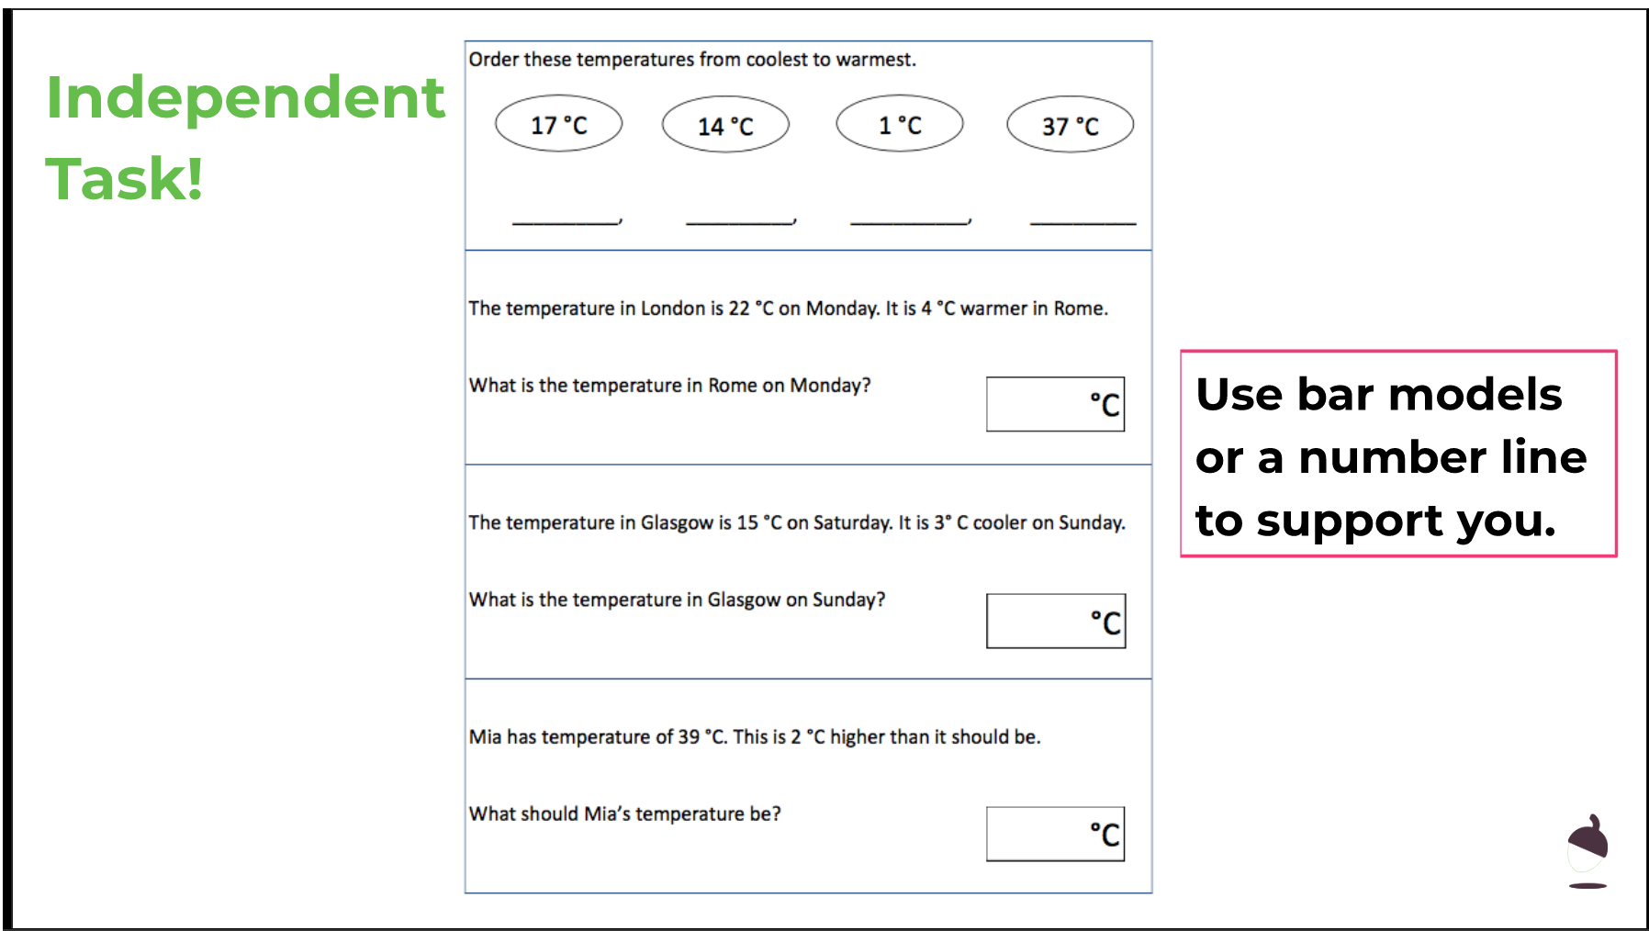
Lesson 2 – Maths Independent Activity
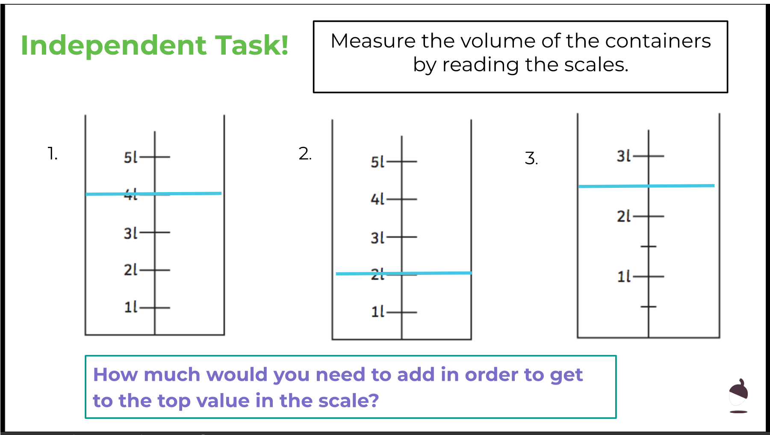

Lesson 3 Maths Independent activity
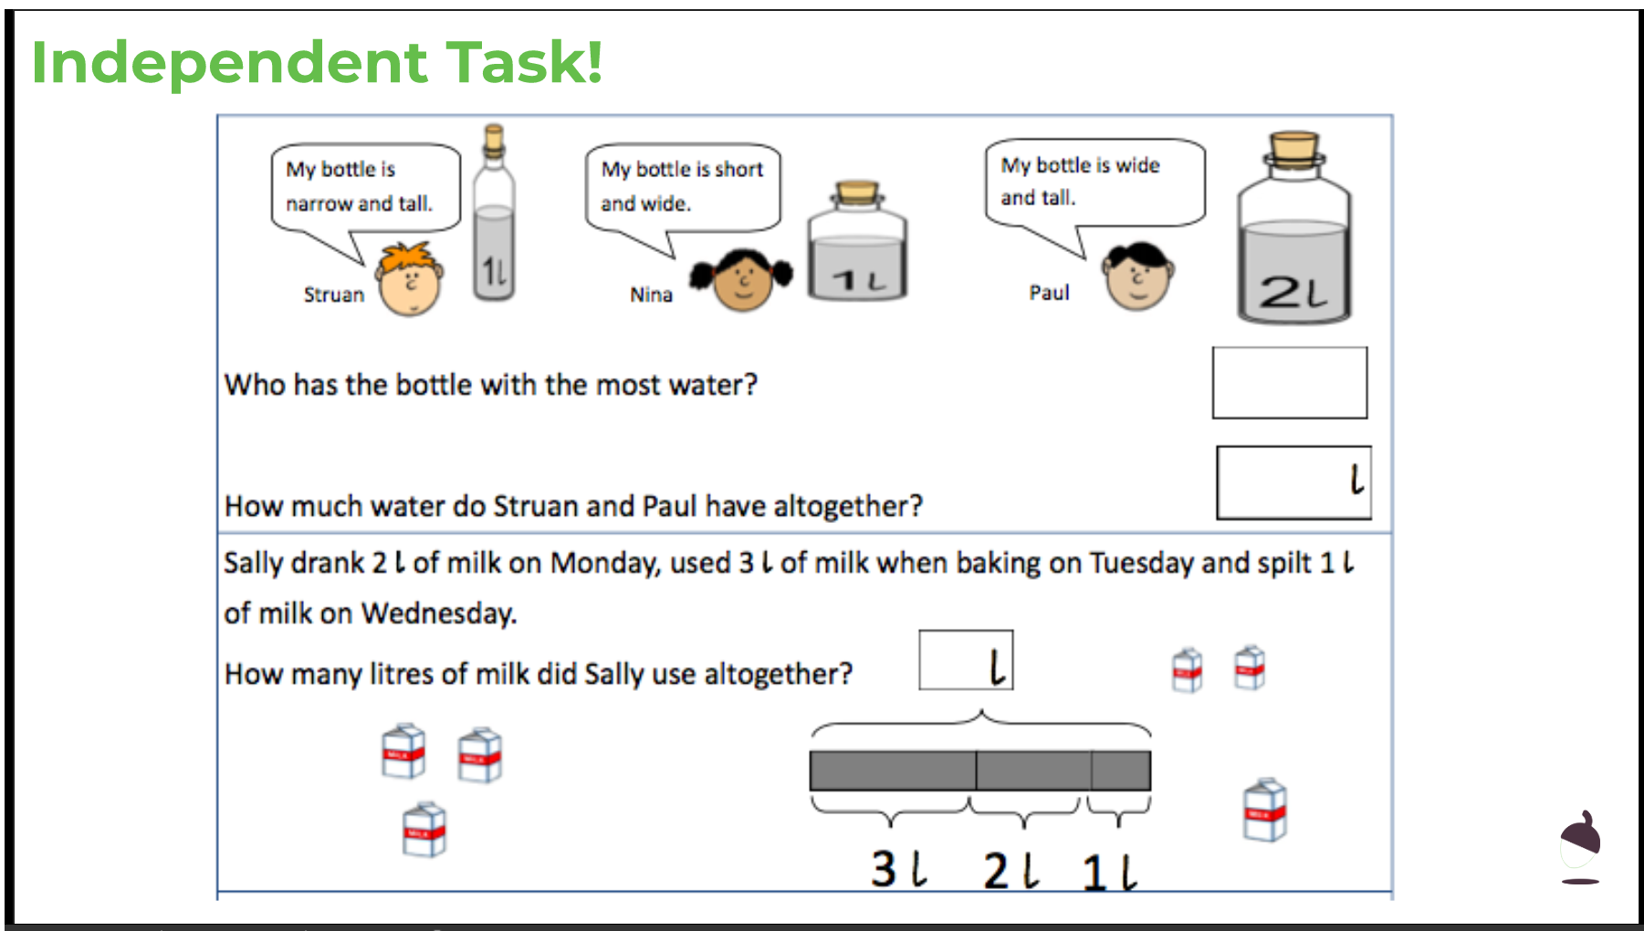
Lesson 4 Maths independent activity
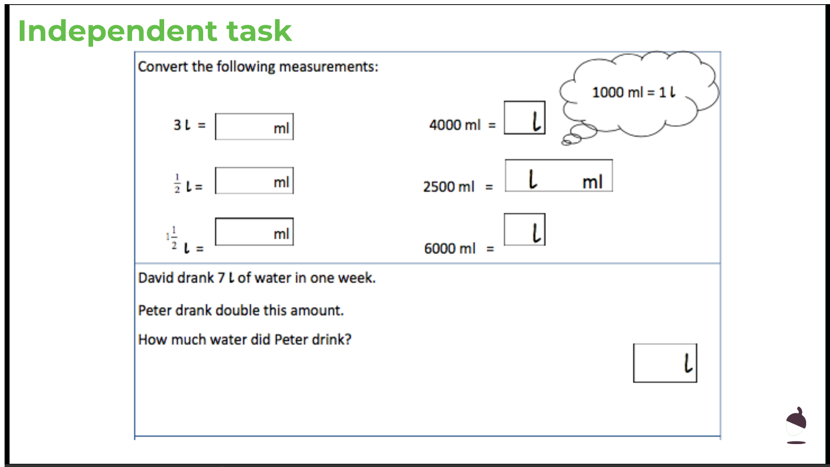
Lesson 5 Maths independent activity
