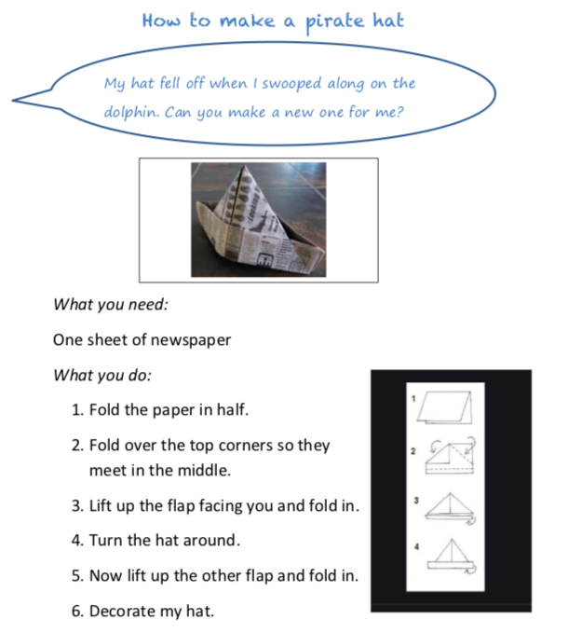
Get as creative as possible and make your pirate hat unique!

Take a picture of your creation.

