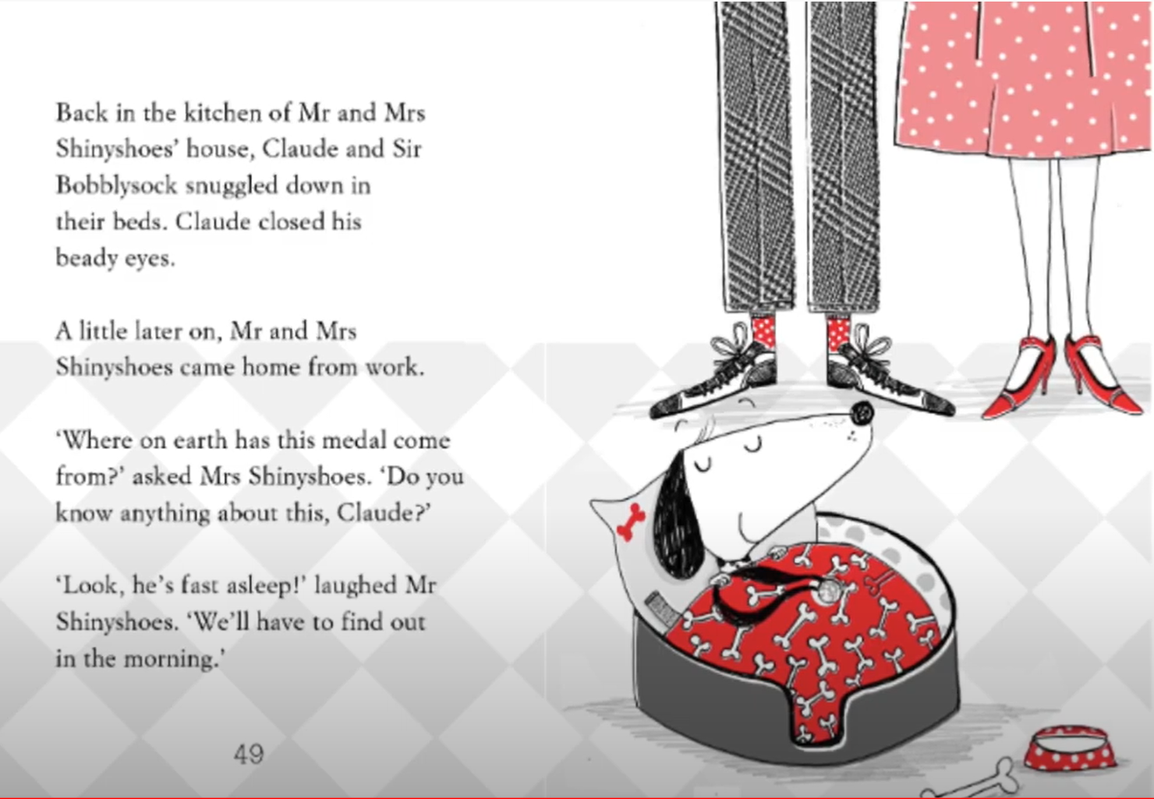
What do you predict will happen in part 2 of the story?

