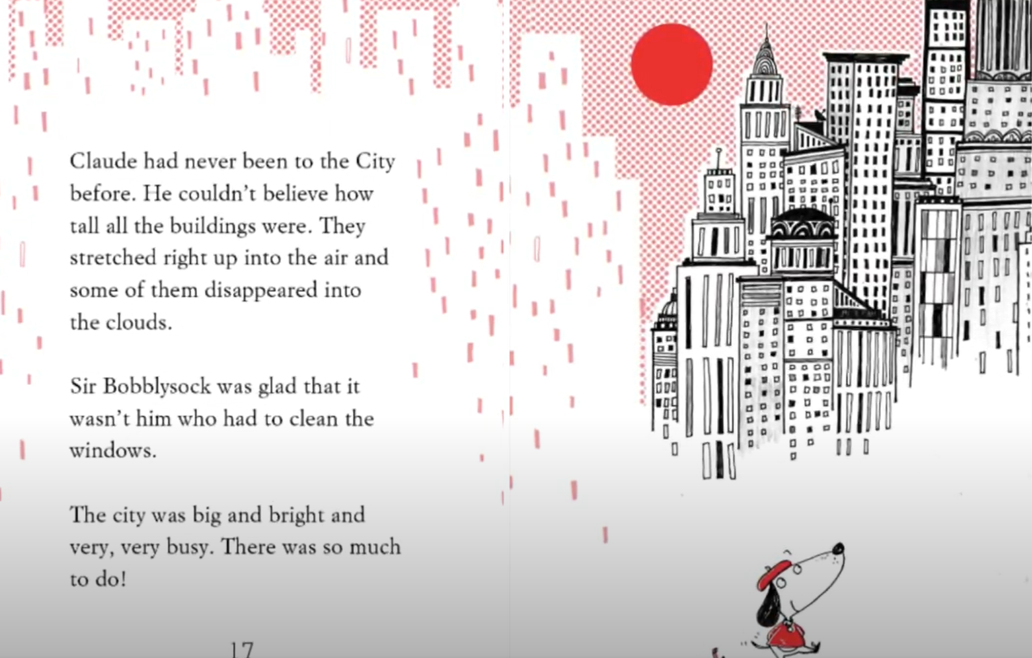
Think about a City you know. This could be London.
Claude thinks there is so much to do in a City. Can you think about what you can do in Cities and make a list for Claude.

