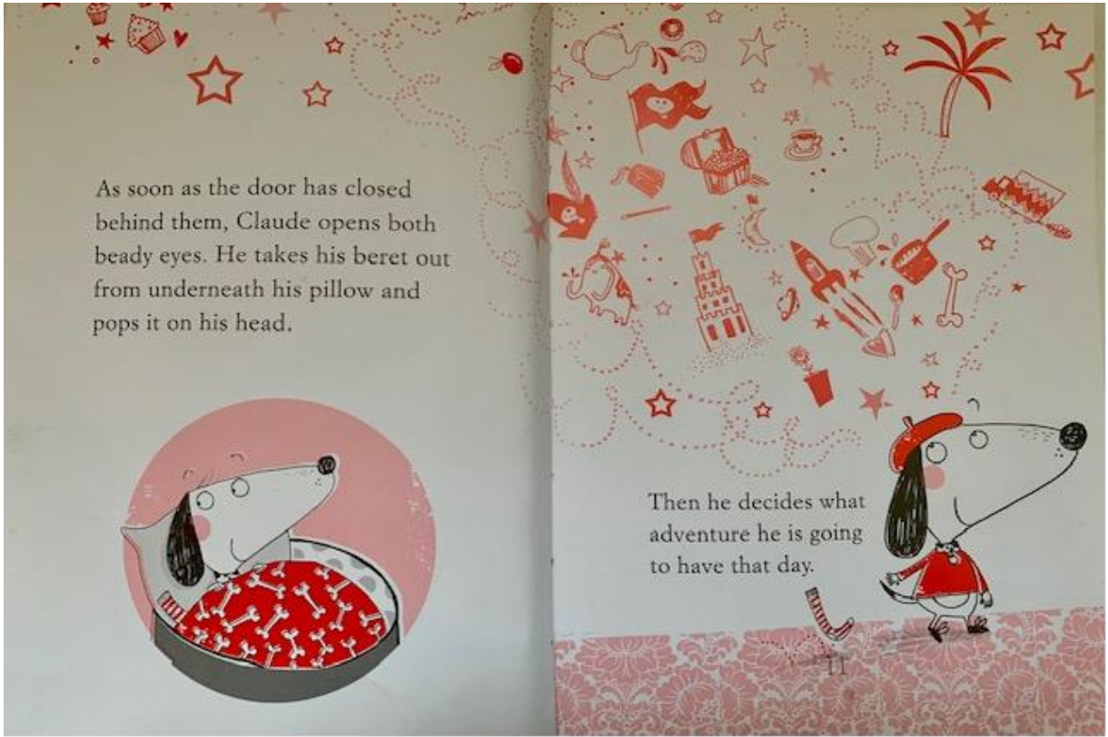
Let’s think about the adventures he may have.
- Who might he have these with?

- What kind of adventures might these be? – look at the illustrations

- What is Claude interested in? – look carefully at the illustrations

- What is happening in his imagination as he thinks about this?

- What does this tell you about the story that might lie ahead?

