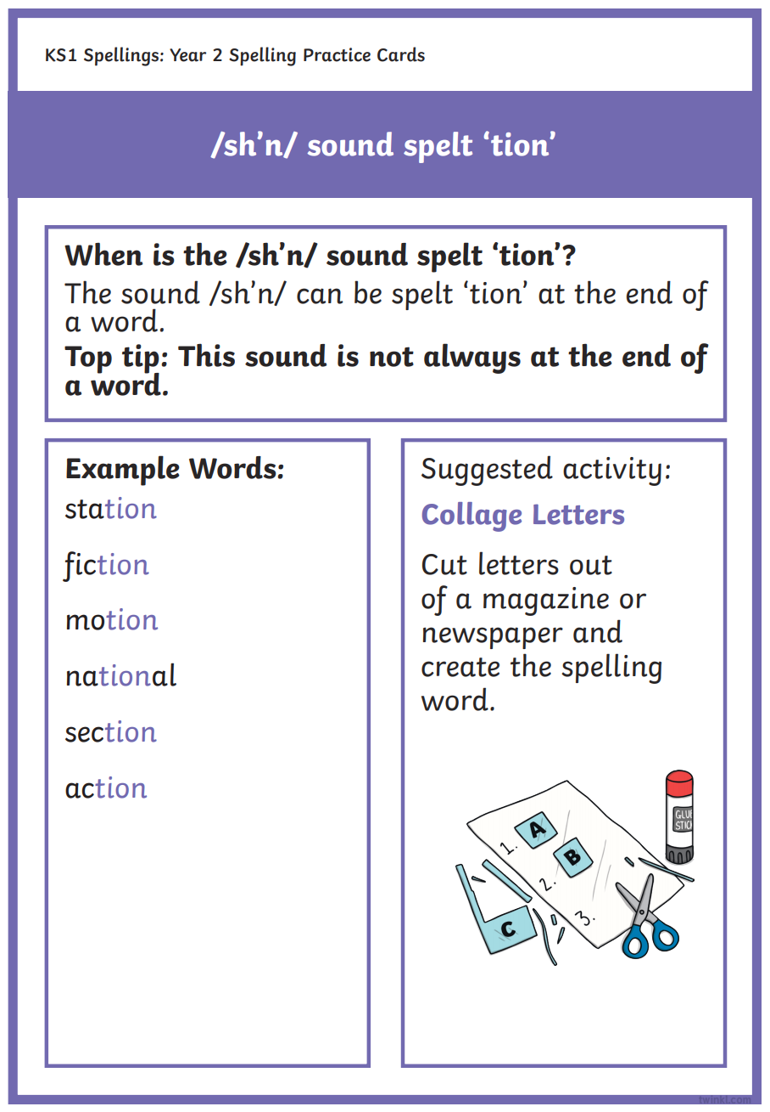
Can you think of any more -tion words?
If you cant cut out and stick maybe you could think of a different way to learn the words.

