Look at this double page from the story.
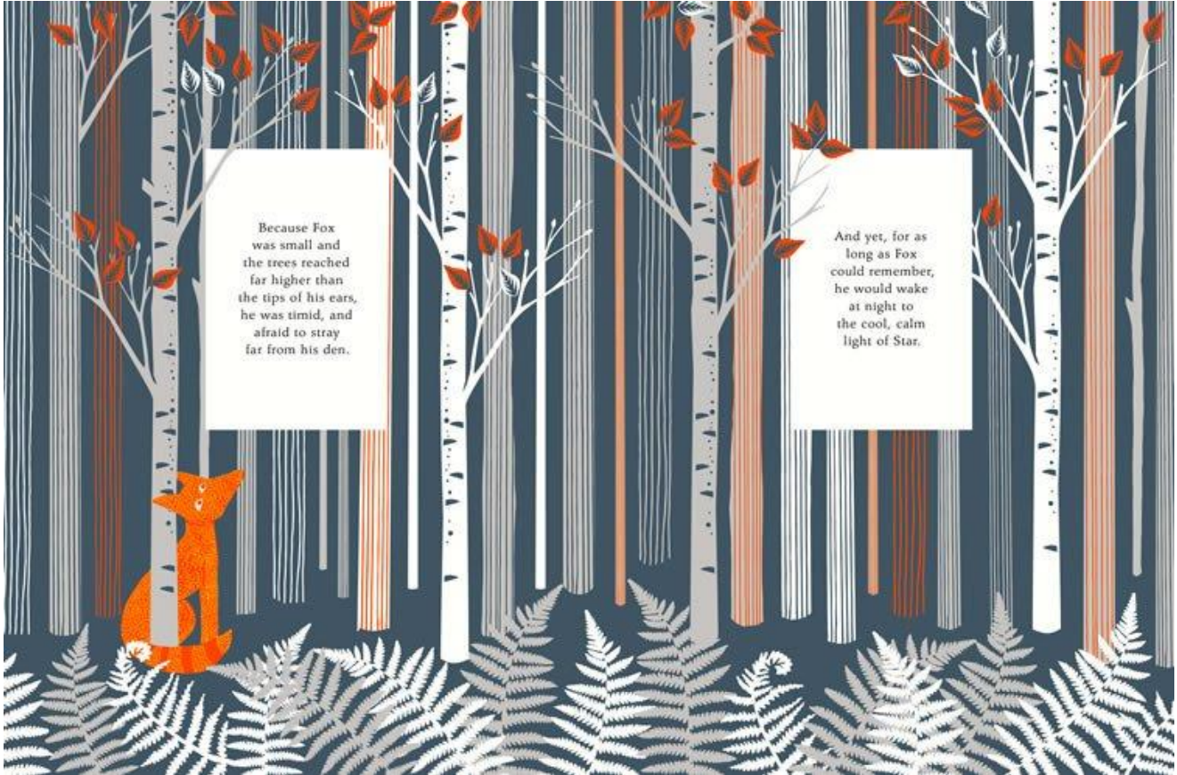
Have a close look at the illustration and then read the text.
‘because fox was small and the trees reached far higher than the tips of his ears, he was timid and afraid to stray far from his den’
‘And yet, for as long as he could remember, he would wake at night to the cool, calm light of the Star’
Discuss these questions with an adult or sibling and then have a go at answering in full sentences.
What is happening here?

Where is it happening?

How does the fox feel about the forest? What words in the text tell us this?

Look again at the place described in the picture.
What words or phrases would you use to describe it?

What time of year do you think this might be? What makes you think this?

What does he think about Star? Is this how you feel about the stars? Why? Why not?

