Look at the title and the front cover.
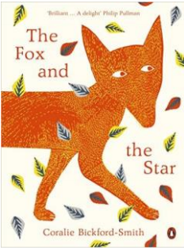

What do you predict this story will be about?

What makes you think that? Can you explain why?

