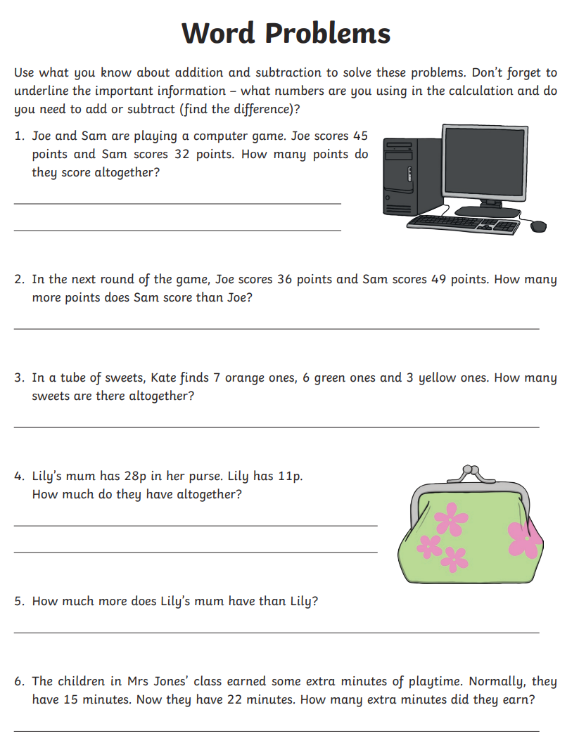
You can work out your answers on some spare paper then write your answers here.
1.
2.
3.
4.
5.
6.

