**Green and Blue group: Different points of view**

Take a look at the photos below of the different types of people involved in D-Day before, during and after. Based on the evidence in the photos, what do you think they might be thinking?

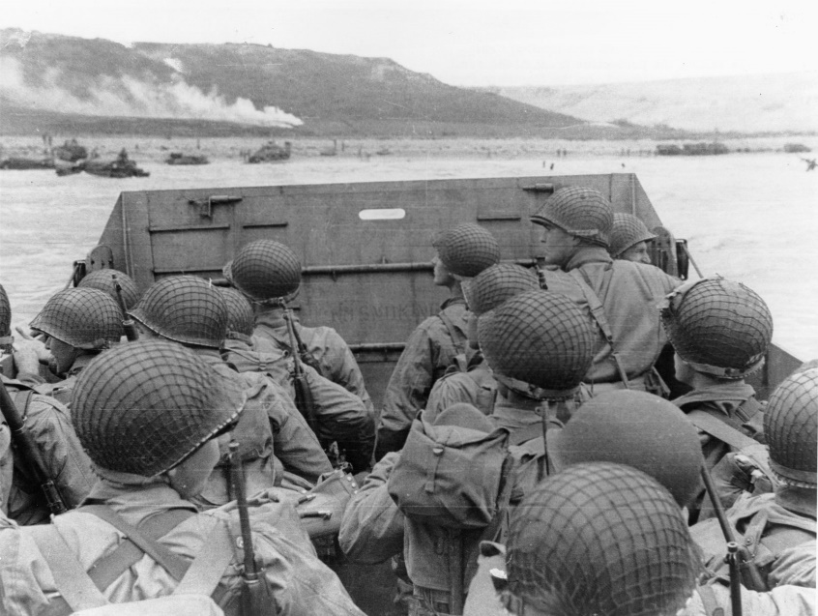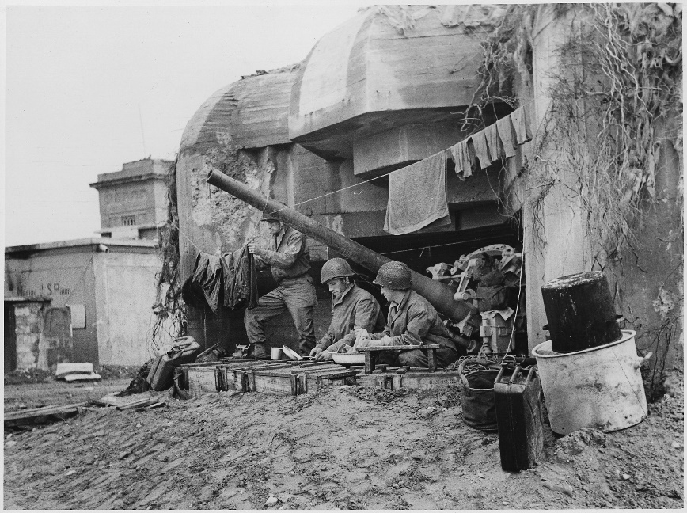

American soldiers waiting to run ashore onto the beaches to attack the Germans.

German soldiers protecting their section of French land that they had taken over.

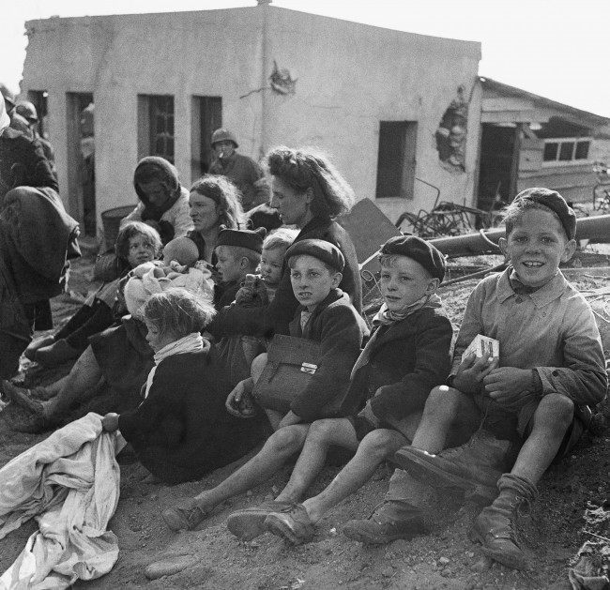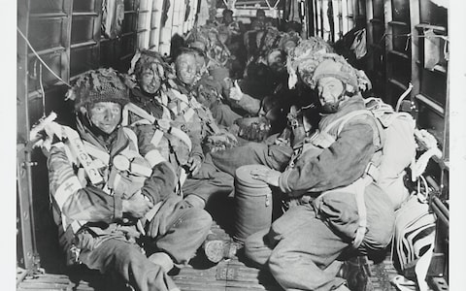

French children after the American soldiers had arrived in their village to free them from German control.

British paratroopers flying over to France ready to jump out of the plane and parachute into the enemy area.