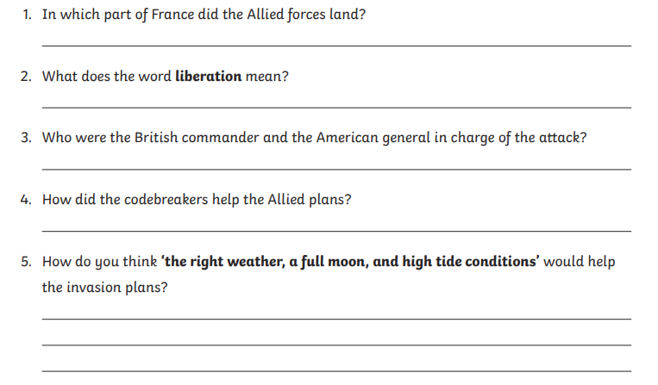**Green and Blue group questions – Tuesday**