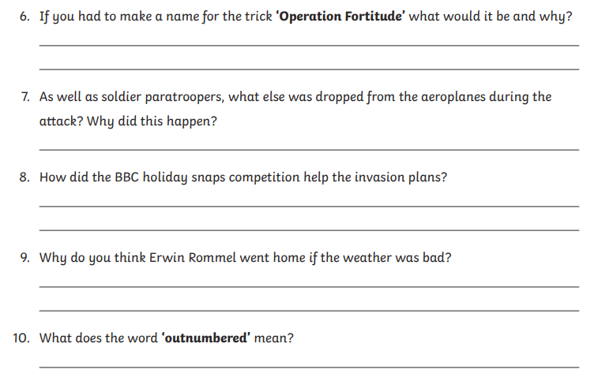**Green and Blue group questions – Wednesday**