Home Learning Timetable Year 2- Summer 2 - Week 4 - Week beginning – 22.06.2020
Monday | Tuesday | Wednesday | Thursday | Friday
Take 10
Complete 10 minutes of daily physical activity. This could be skipping, running, dancing or see joe wicks cards for ideas. OR Join Joe Wicks on YouTube for daily 30 minute home PE sessions at 9AM (see link below)
MUSIC:
Singing Assembly https://www.youtube.com/watch?v=hzlzbCcWMr4 – Please have a look at this week’s Singing assembly.
Music Challenge 11 – Genre of the Month fact file https://youtu.be/kj6UJEDMNKs - Join in with the music challenge.
Reading – Prediction  Have a look at the title of the text we will look at this week.  ‘The Fox and the Star’  Can you make a simple prediction about what you think it might be about. | Reading –  Can you research and read about a famous Olympian. Here are some examples: -  Mo Farah  Usain Bolt  Keely Holmes  Michael Phelps  Laura Trott | Reading -  Fox comprehension Activity -Read the text about Foxes and answer the questions. | Reading –  Listen to the story ‘The fox and the star’ on youtube.  Once you have listened to the story. Think about if your prediction was correct. Did you enjoy the story? Did anything surprise you?  https://www.youtube.com/watch?v=C7kDf-8bqs8 | Reading -  Can you go online and read about the London Olympics 2012.  What can you find out about the Olympics. The London Olympics took place just before Year 2 were born! Ask your parents what is was like!  https://www.olympic.org/london-2012
Maths Focus this week is Exploring Calculation Strategies:
This week we are focussing learning on addition. To help support your child’s learning of Addition there are 5 lessons on the Oak Academy website. Each day the site will provide a lesson. It will have a video to explain the learning and will provide some activities. Children can also complete a little quiz at the end of the session.
https://www.thenational.academy/online-classroom/subjects/#subjects
Click on year 2 - Maths – then scroll down to Exploring Calculation Strategies. We are starting with lesson 1

Maths  Lesson 1 - To apply addition strategies to solve equations  See online activity sheet  Additional  Monday maths Sheet | Maths  Lesson 2 - To apply subtraction strategies to solve equations  See online activity sheet  Additional  Tuesday maths Sheet | Maths  Lesson 3 - Solving word problems  See online activity sheet  Additional  Wednesday maths Sheet | Maths  Lesson 4 - Solving comparison word problems  See online activity sheet | Maths  Lesson 5 - Adding 2-digit numbers  See online activity sheet  Additional  Friday maths Sheet
Literacy – Explore it.  Have a look at the double page picture from the text The fox and the star’  Then work through the questions to help you explore the text and the illustration in more detail. | Literacy – Fact File  After researching your Chosen famous Olympian. Can you write some facts about them.  What is their name/age?  What was there sport?  What Olympics did they take part in?  What medals did they win?  Interesting facts. | Literacy ––Illustrate it  ART What do you think Fox sees as he gazes up into the night sky? Draw a picture of the night sky. You might draw the tops of the trees, the night sky filled with stars, the moon.  Under your picture can you write some sentences using adjectives to describe the night sky. | Literacy - Write about you and your friend.  Fox and Star are special friends. Do you have a special friend?  Why are they your special friend? Draw a picture of you and your friend and write about your friendship. Have a look at the questions on Thursday Literacy sheet and write about you friend. | Literacy - Write your friend a letter  Have a look at the letter template and some suggestions to write about. You might like to include a drawing in this letter or even a poem or a joke.  Keep your letter safe to give to your friend when you see them next or if you know where they live you could post it.
Daily Phonic Lesson: -  Year 1 – Summer Lesson 21  ie – field  https://www.youtube.com/watch?v=d9V0zAeX4oI&list=PLuGr6z2H2KNGObda6B-T36vJlZYN06lOh&index=21 | Daily Phonic Lesson: -  Year 1 – Summer Lesson 22  er– herb  https://www.youtube.com/watch?v=Ffjnh3muZow&list=PLuGr6z2H2KNGObda6B-T36vJlZYN06lOh&index=19 | Daily Phonic Lesson: -  Year 1 – Summer Lesson 23  oe – toe  https://www.youtube.com/watch?v=uIyVBLXuGDA&list=PLuGr6z2H2KNGObda6B-T36vJlZYN06lOh&index=17 | Daily Phonic Lesson: -  Year 1 – Summer Lesson 24  u - music  https://www.youtube.com/watch?v=9JvpmcawC08&list=PLuGr6z2H2KNGObda6B-T36vJlZYN06lOh&index=15 | Daily Phonic Lesson: -  Year 1 – Summer Lesson 25  i - kind  https://www.youtube.com/watch?v=HizM9tPsLns&list=PLuGr6z2H2KNGObda6B-T36vJlZYN06lOh&index=13
Virtual Olympics  Enfield Town School's Partnerships have organised a Virtual Summer Olympic's for all the schools to take part in.  Read the information provided on the PowerPoint: 2020 Virtual Summer Olympics  Then open the file:  Virtual Summer Olympics challenge card  This will be your personal form to fill out and will be on going.  The deadline is 3rd of July. Details on how to send your results in can be found on the final slide of the PowerPoint.  Any further questions about the challenge can be emailed to the school office for the attention of Miss Conway.  Good Luck! | Olympics – Active Section  Choose an activity from the Active Section. Practice your activity today and take some pictures.  You are doing very well so far, keep going! | Olympics – Active Section  Choose another activity from the Active Section. Practice your activity today and take some pictures.  You’ve been a fantastic team player! Keep pushing yourself. | Olympics – Educational Section  Today have a look at the educational section. You can choose one activity. Will you choose to take part in the reading challenge or complete a Fact file about Turkey – remember the more facts the more points!! Or will you complete the Quiz? Come on Year 2 – We can do this! | Topic – ART  Can you make a flag for your Olympic games – Think about our school logo, Our School code or the activities you have chosen to help you design your flag.   Practice your chosen sports so far.
Spellings - Homophones  This week we will begin to work through some spelling challenge cards.  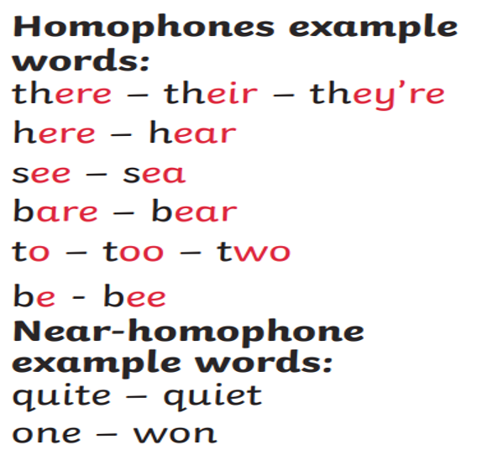 | Handwriting  Practice 2 joins –  Put these words into sentences in your neatest writing.    Fruit, suit, juice  Claw, straw, saw, | Spelling - contractions  Have a look at the challenge card for today.  We are looking at contractions.  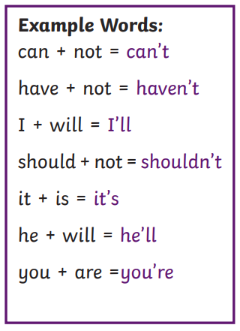 | Handwriting  Practice 2 joins –  Put these words into sentences in your neatest writing  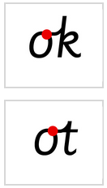  Okay, look, token  Hot, bottle, note | Spelling – tion  Have a look at the challenge card for today. We are looking at words ending with -tion.  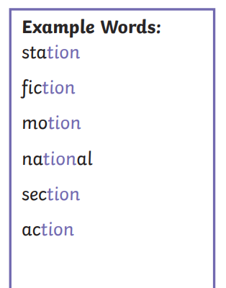
Story time
Ask your parent/ carer/ sibling to read to you at bedtime. OR read a book yourself for 10- 20 minutes before you go to sleep
Mindfulness
Enjoy a quiet session of mindfulness. Join gonoodle and select an activity. https://family.gonoodle.com/channels/flow

Links to websites
Maths:
Oak National Academy
https://www.thenational.academy/online-classroom/year-2#subjects
TT Rockstars
https://play.ttrockstars.com/auth
Use this to improve your multiplication.
All Other subjects
Purple mash – various activities to explore. Class teacher may also suggest an activity to complete on the timetable.
Twinkl - There are lots of additional support materials on this website for parents and children.
Think about all the subjects you find challenging, can you find some extra work to complete to support your learning. .
Science:
Explorify https://explorify.wellcome.ac.uk/ - have a look and see if you can complete a fun science experiment
Woodland Trust - Activities for children if you are self-isolating
https://www.woodlandtrust.org.uk/blog/2020/03/kids-nature-activities-self-isolation/

DT – Food Tech
Some ideas for getting children involved with cooking
https://www.bbcgoodfood.com/recipes/category/family-kids

Joe Wicks – PE for kids
And just in case you’ve missed this. A daily session for children
https://www.thebodycoach.com/blog/pe-with-joe-1254.html

If you need any help with the work please email the school office office@keysmeadow.enfield.sch.uk
Your message will be forwarded and returned by the class team as soon as possible.

