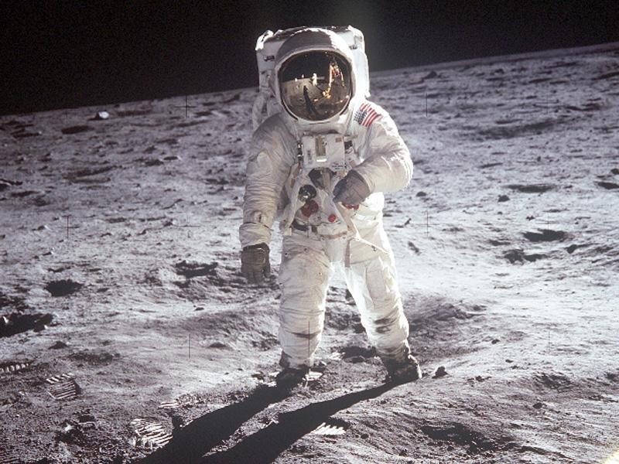**Real photograph of an Apollo 11 astronaut on the moon**