**Reasons to suggest that the Apollo 11 mission was faked!**

1. You can tell Apollo 11 was faked because ...the American flag appears to be flapping as if "in a breeze" in videos and photographs supposedly taken from the airless lunar surface.

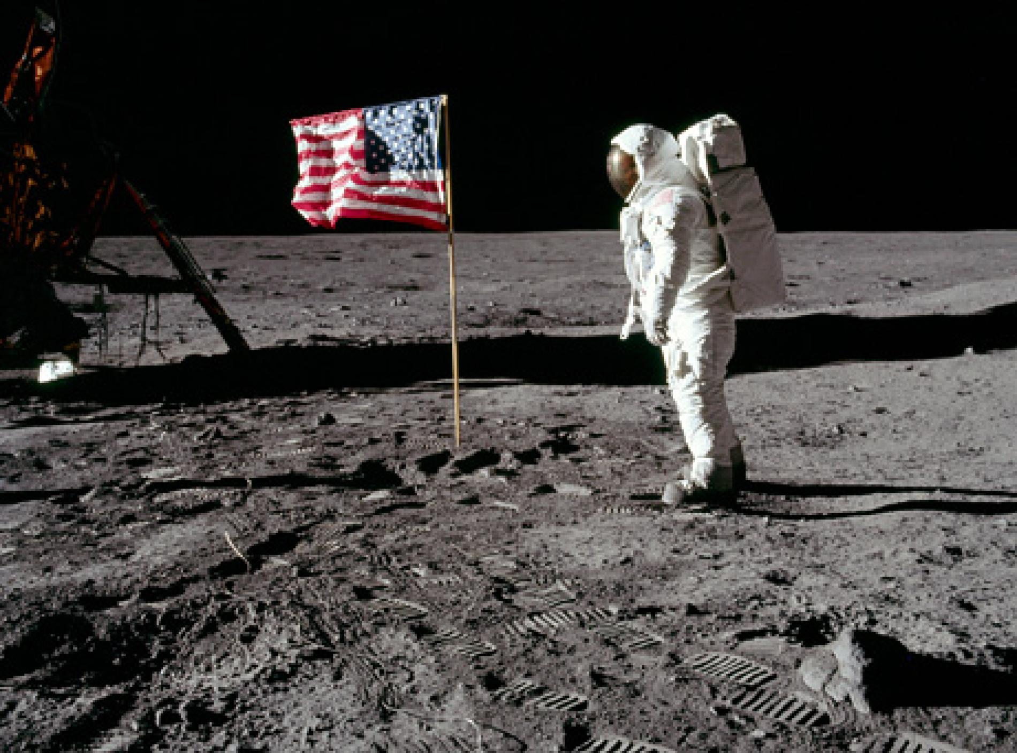

1. 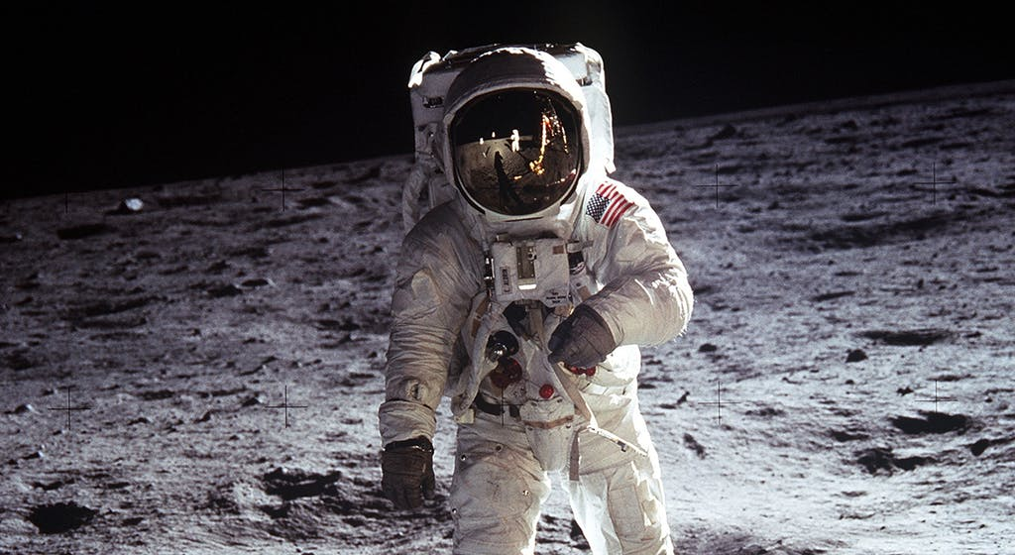You can tell Apollo 11 was faked because ...only two astronauts walked on the moon at a time, yet in photographs such as this one where both are visible, there is no sign of a camera. So who took the picture?
2. 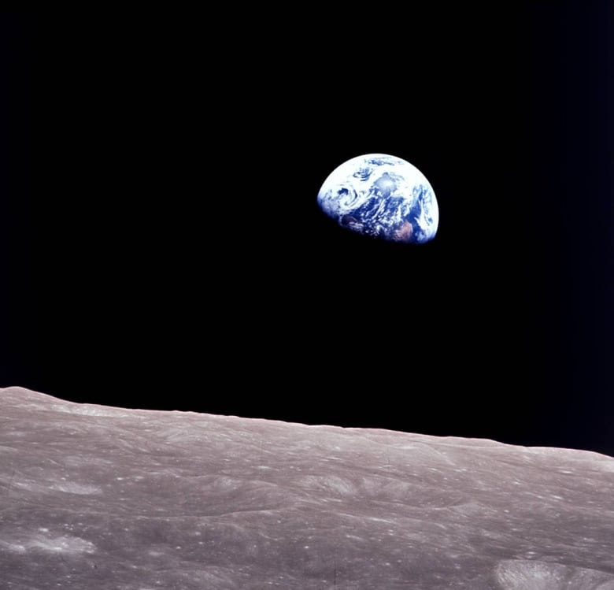There are no stars at all in any of the photographs from Apollo 11.
3. The Lunar module is seen resting peacefully on a flat surface. Why was there no dent as it landed? In addition to this, why does it look like no dust had been flying around?

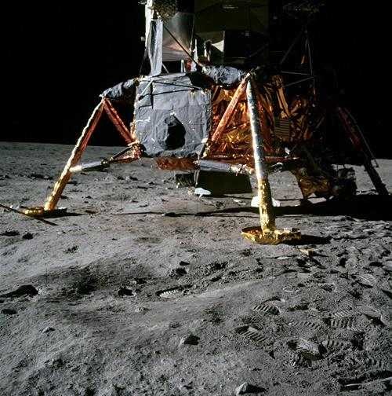

1. 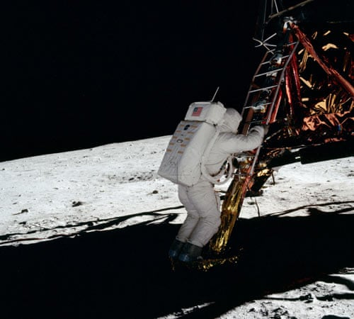Buzz Aldrin is seen in the shadow of the lander, yet he is clearly visible. Hoax subscribers say that many shadows look strange in Apollo 11 pictures. Some shadows don't appear to be parallel with each other, and some objects in shadow appear well lit, hinting that light was coming from multiple sources—suspiciously like studio cameras.
2. 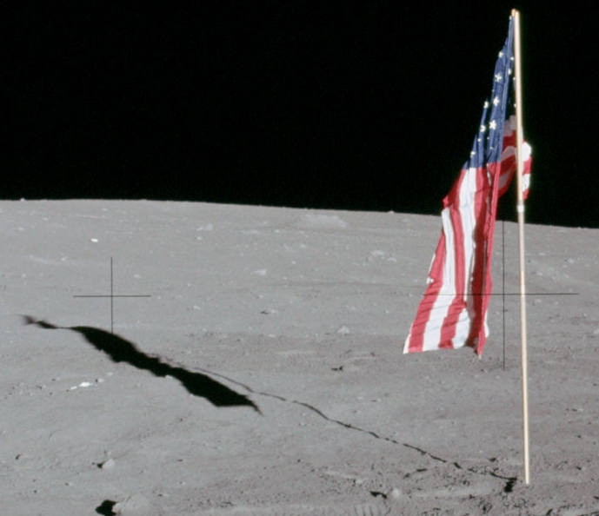When Apollo 11's Armstrong and Aldrin took off from the moon in July 1969, they left behind part of the Eagle, the U.S. flag, and several other instruments and mementos. With instruments such as the Hubble Space Telescope capable of peering into the distant recesses of the universe, surely scientists should be able to see the various objects still on the moon. But no such pictures of these objects exist.