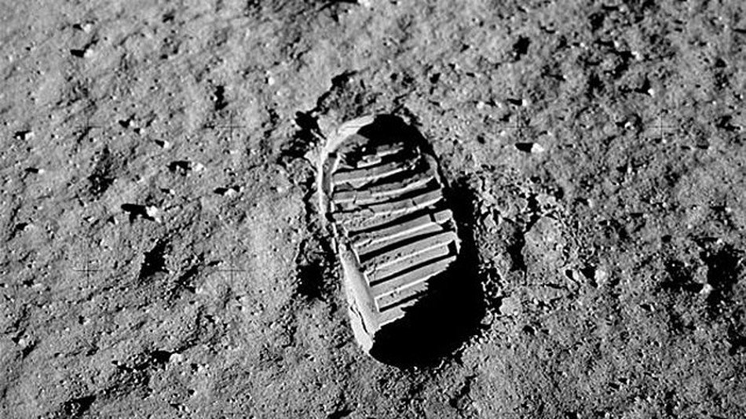**Footprint from an Apollo 11 astronaut on the moon**