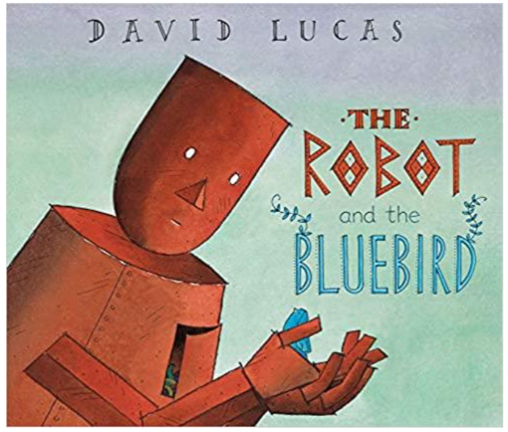
Here is the front cover and title of the new book you will be looking at during your home learning this week.

Read the title and have a look at the front cover
Can you make a PREDICTION?

Who do you think the story is about?

What do you think will happen in the story?

