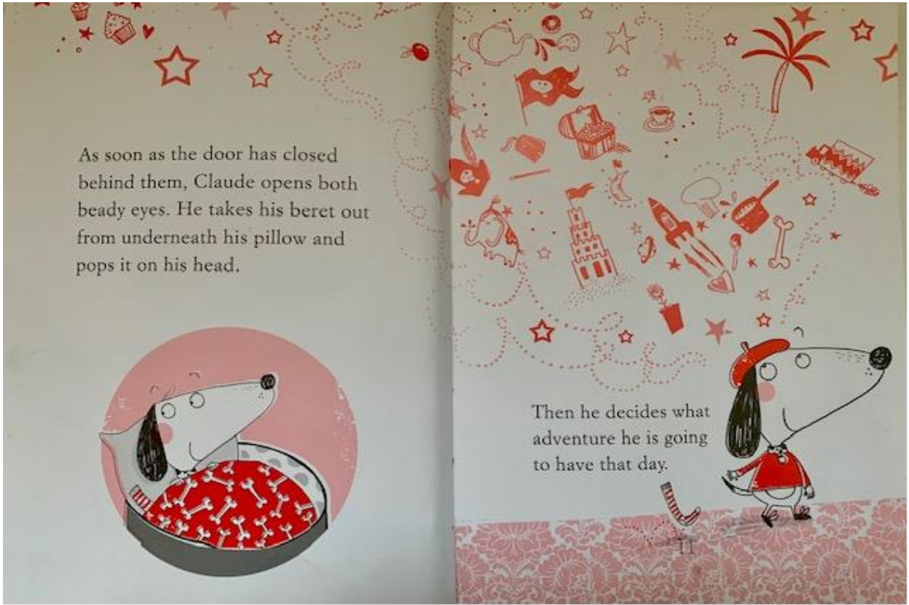
Look at and read the spread from the book.

Who is the character?

What do you think you know about Claude? - You might think about where he lives, what he does, what he looks like, how he behaves and how he feels.

What in the words and pictures gives you clues about his character?

