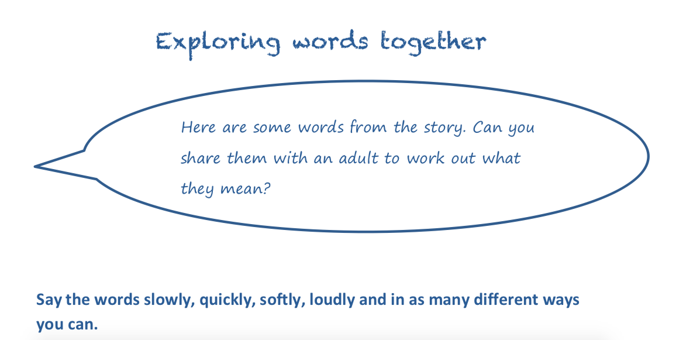

Show your grown up how you can
swoop ... glide ... fly like the creatures in the story.

Show your grown up how you can
swoop ...
glide ...
fly…
like the creatures in the story.
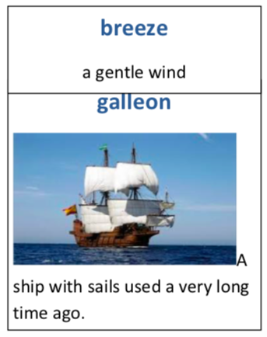
Challenge:
Put all these words into some interesting and exciting sentences!

