Remember we start by adding the ones column first. Then we add the tens.
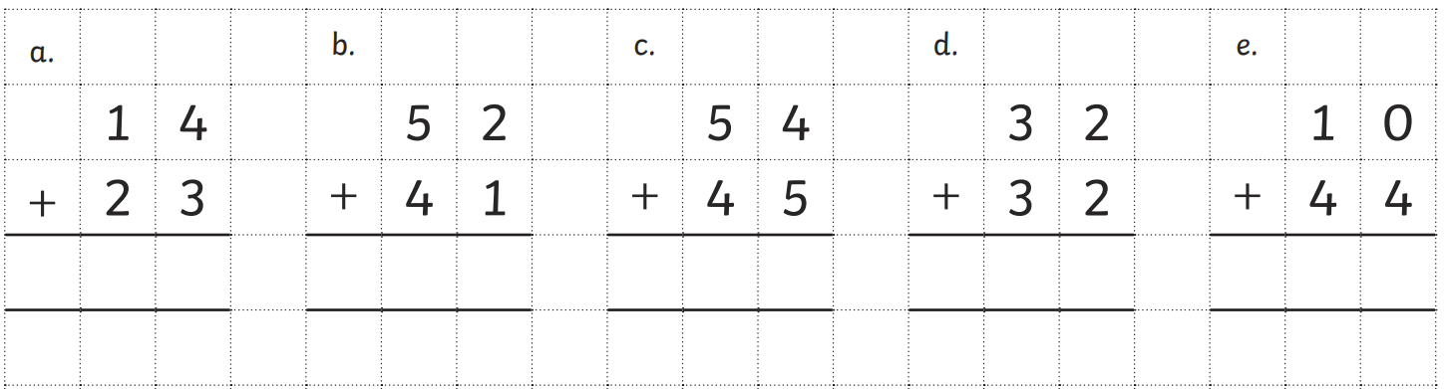

Exchanging
Sometimes when we add the ones we might need to exchange them for a ten. If the number is more than 9 then we will ned to place the ten digit in the tens column.
See example below:
