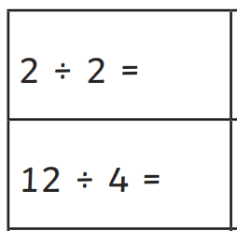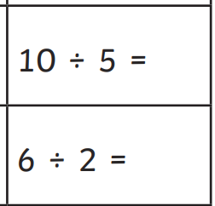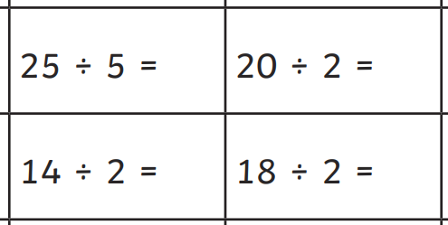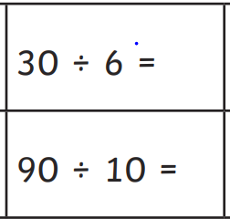
Remember when we complete division questions we also draw groups to help us share out equally.
BUT we will only count ONE group to find the answer.
For example: Share out 24 into 6 groups.
24 ÷ 6 =

We then count 1 group only to find the answer.
24 ÷ 6 = 4

