Treasure maps!
Can you make a treasure map with your grown up? This web link will help you.
https://theimaginationtree.com/diy-pirate-map-and-treasure-hunt-games/
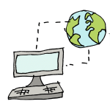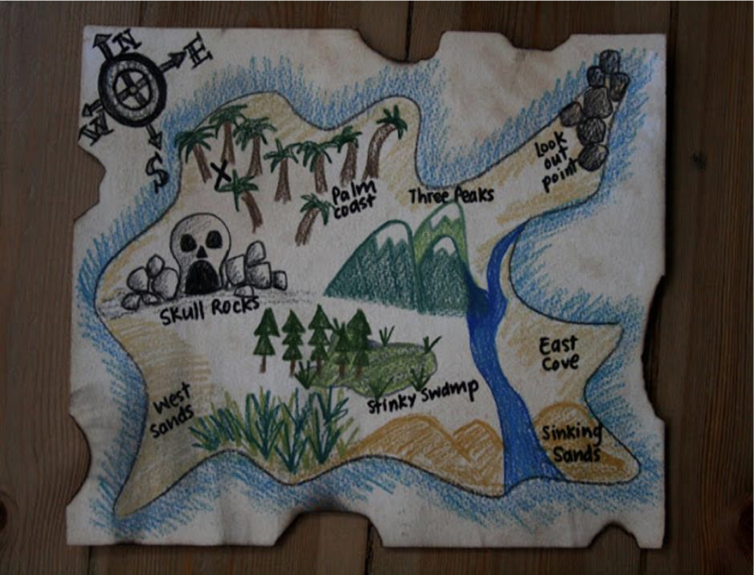
When you've made your map, can you make up a story about hunting for treasure?

