Remember we start with the ones column first.
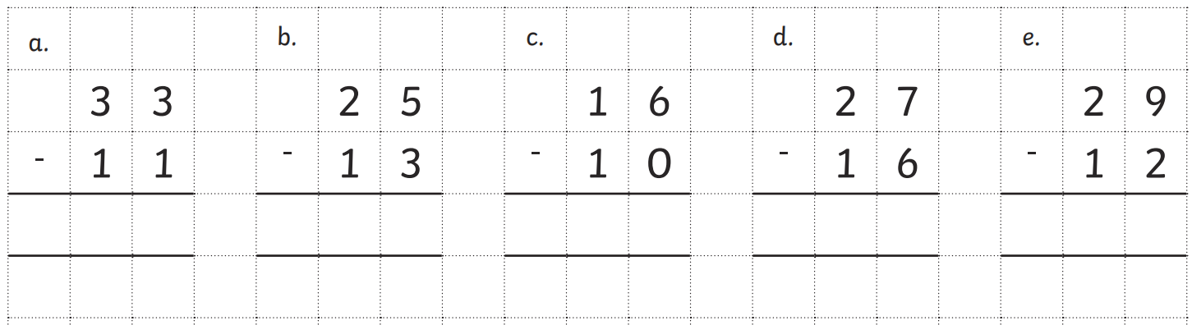

Exchanging
Sometimes when we subtract the ones we might need to exchange a ten so we have a bigger number of ones to subtract from.
See example below:
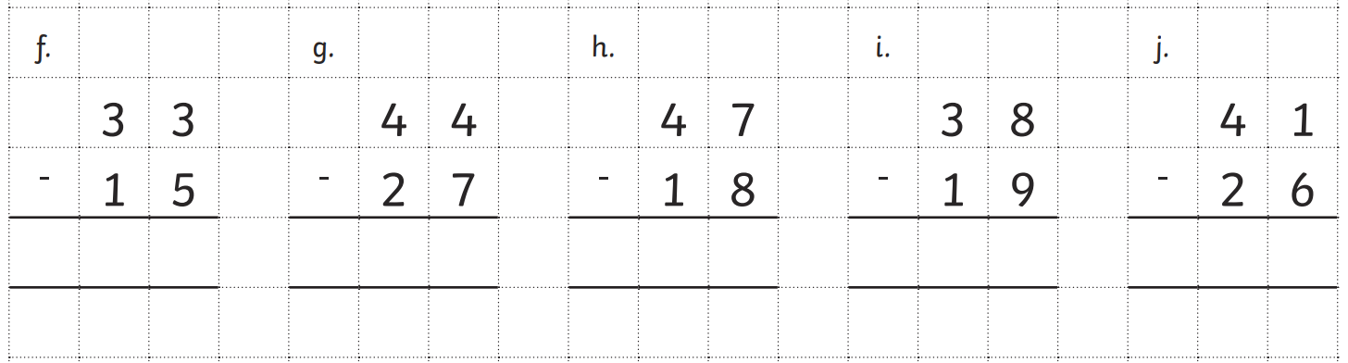
Example:
3 – 5 = we cant do this as we don’t have enough to take 5 away so we need to exchange a 10 for 10 ones.
13 – 5 = 7
Then we now have 2 – 1 = 1

