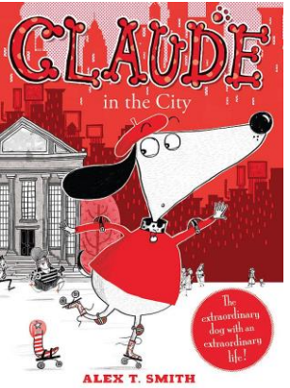

Now look at the front cover above and read the title.

- What more have you learned about Claude?

- Where is he and what is he doing?

- How is he feeling now? How do you know?

- Why might he be pulling this face?

- What might happen in this story involving Claude and any other characters you notice?

His sock friend is called Sir Bobblysock. Would you like to meet him and Claude? Why? – Talk to an adult and explain your reasons
Do you know any other story character dogs in books, comics, film or television?
.

