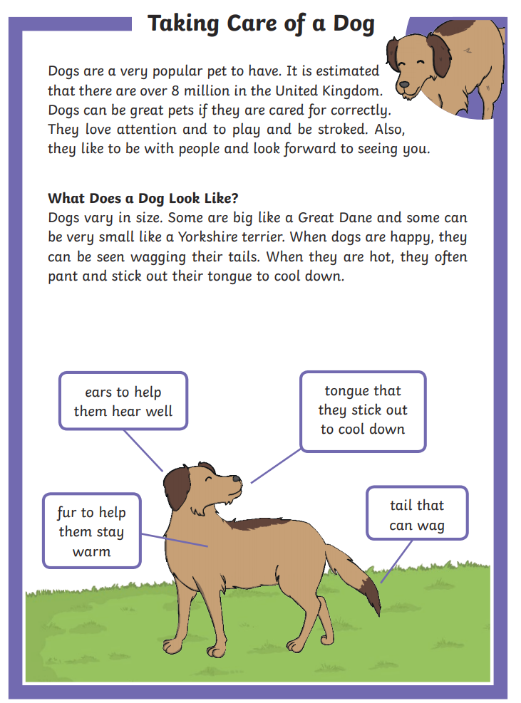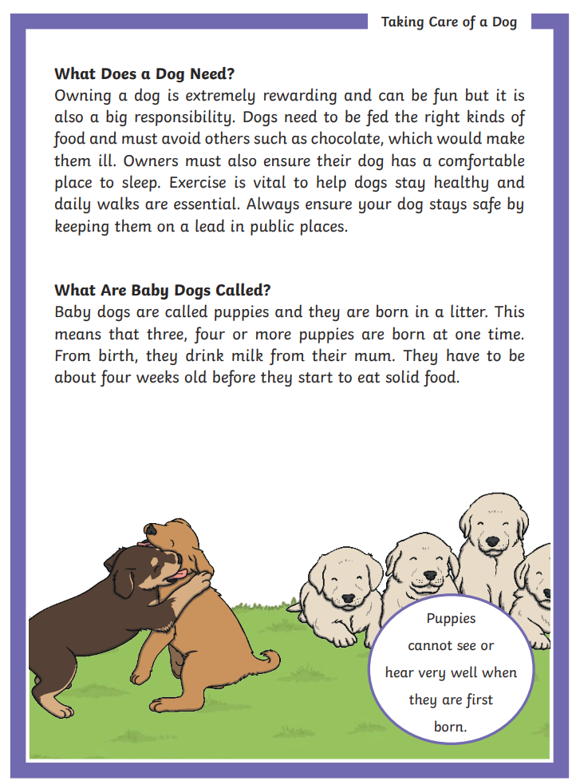

QUESTIONS

- Roughly how many dogs are there in the United Kingdom?
- Under 8 million
- 8 million
- Over 8 million

- How do dogs cool themselves down?

- Why is having a dog a big responsibility?

- Find and copy one word that means ‘stay away from’.

- How can a dog be kept safe in public places?

- Why do you think dogs are such a popular pet in the UK?

