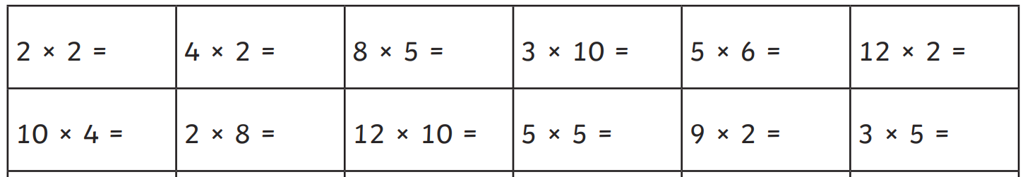
Remember when we complete Multiplication questions we need to draw groups of.
So for example –
5 x 7 =

Then count all the groups TOTAL = 35

