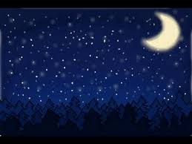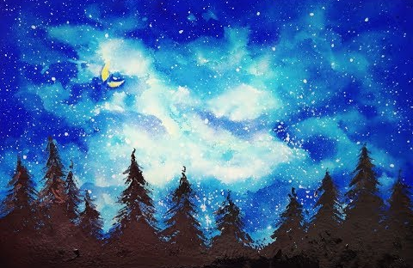

Key words
Midnight, Dark, blue, Enormous, Bright, Sparkling, Dazzling, Shining, Twinkle, clear,
Can you think of any more to help describe your night sky?

