**Citizenship Session 2 – Diversity**

Task 1 – What does ‘diversity’ mean?

Have a think, or discuss with an adult, about what diversity means. Can you explain what it means in your own words?

_____________________________________________________________________________________________________________________________________________________________________________________________________________________________________________________

Task 2 – Imagine you could only eat one type of food for the rest of your life. Or maybe you could only listen to music by one artist. Or play one type of game. Or watch one type of sport.

Would you be happy with this? Explain why/why not.

__________________________________________________________________________________

__________________________________________________________________________________

__________________________________________________________________________________

__________________________________________________________________________________

No matter how good that food, music, game or sport is, it’s always good to have some diversity. It is the same with people.

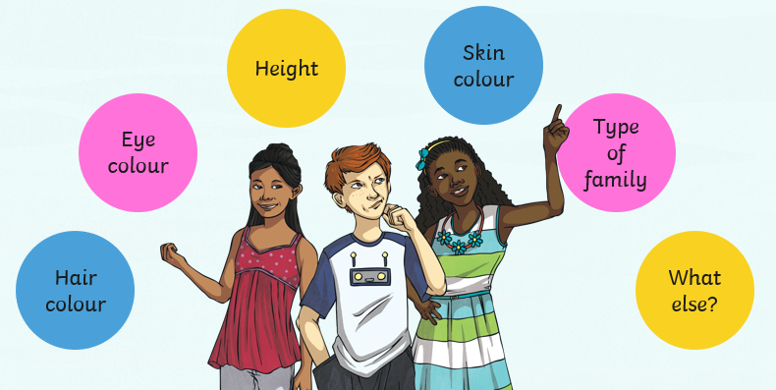Think about your friends and family. Think about your similarities and your differences.

Much of Britain’s cultural diversity is due to immigration to the country. People migrate to Britain for many reasons – for work, to be near family, because they like the culture - and have done so for many centuries.

Here are some opinions that are sometimes expressed by people about the positives and negatives of living in a multicultural society. Do you agree with them?

* Food available in Britain is varied and uses ingredients and flavours from around the world.
* Premier league football players come to play for English clubs from across the world, meaning British football is some of the most exciting and skillful in the world.
* Events like the Notting Hill Carnival showcase a range of different musical styles
* Racism is sometimes a problem, and some people don’t agree that people should be allowed to migrate to Britain.
* People in Britain can meet and be friends with people from all over the world.
* Having lots of people with diverse experiences and backgrounds means that Britain has become a more tolerant and kinder society.
* The NHS has skilled doctors and nurses from around the world.
* Clashes between cultures can lead to religious discrimination, and even terrorist attacks.
* Some people think that Britain doesn’t have a strong cultural identity because it is so diverse.
* Over 100 different languages are spoken in London.
* People in the UK have easy access to a range of different foods, fashion, religions and ideas.

You might be able to think of some ideas of your own to add.

Task 3 – In **your opinion**, what are the 3 greatest benefits to living in a multicultural society? Give reasons for your answer.

1. __________________________________________________________________________

__________________________________________________________________________

__________________________________________________________________________

1. __________________________________________________________________________

__________________________________________________________________________

__________________________________________________________________________

1. __________________________________________________________________________

__________________________________________________________________________

__________________________________________________________________________