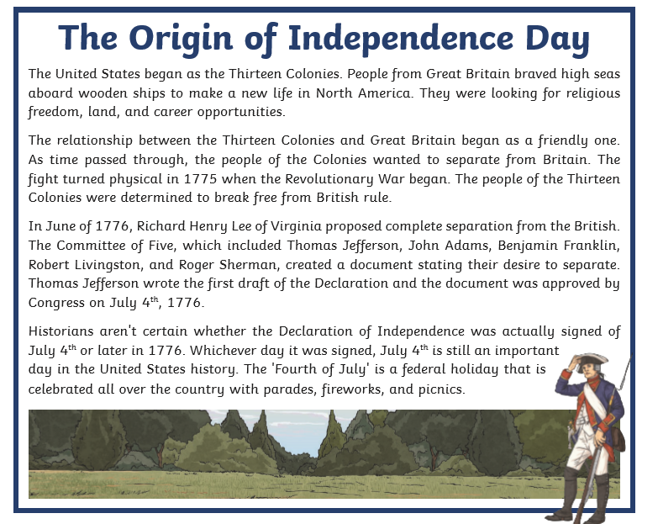**Friday reading task: Independence Day**

**Questions:**

1. *The United States began as The Thirteen colonies.*

Give the meaning of the word *colonies* in this sentence. (1 mark)

_________________________________________________________________________________

1. Look at paragraph one. **Find** and **copy** a phrase which suggests that the journey over to the United States was not easy. (1 mark)

_____________________________________________

1. Highlight the option that best describes the word **revolutionary** in the phrase Revolutionary War. (1 mark)
2. Independent
3. Causing a change
4. Separation
5. Why do you think the colonies wanted to *break free from British rule?* (1 mark)

_________________________________________________________________________________

1. Why do you think July 4th was chosen as America’s Independence Day? (1 mark)

_________________________________________________________________________________

1. List three ways that July 4th is celebrated in the United States today. (2 marks)
2. _________________________________
3. _________________________________
4. _________________________________