**Friday reading task**

Whilst he was in prison, Nelson Mandela found strength and inspiration by reading the poem below. Have a read of it yourself and then have a think about the questions on the following page.

The word *Invictus* means ‘unconquered’ in Latin.

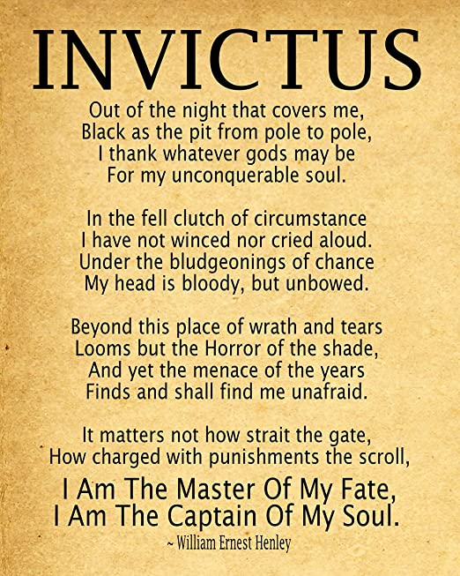

**Reading questions:**

1. What does the phrase *‘out of the night that covers me’* suggest about how Nelson Mandela might have been feeling?
2. Find and copy a word from the first verse/stanza that means ‘cannot be defeated.’
3. *‘I have not winced or cried aloud.’*

What does the word *winced* mean in this line?

1. *‘My head is bloody but unbowed.’*

Highlight the meaning of this phrase from the options below.

1. Someone has hit Nelson Mandela over the head and he has collapsed.
2. Although Nelson Mandela keeps getting hurt, he is standing strong.
3. Read verse/stanza 3.

Find and copy a word which means the same as anger.

1. *‘I am the master of my Fate. I am the Captain of my Soul.’*

What impressions do you get of Nelson Mandela if he was inspired by this line?

1. Can you summarise why you think this poem in particular inspired Nelson Mandela to stay strong during his twenty seven years in prison?