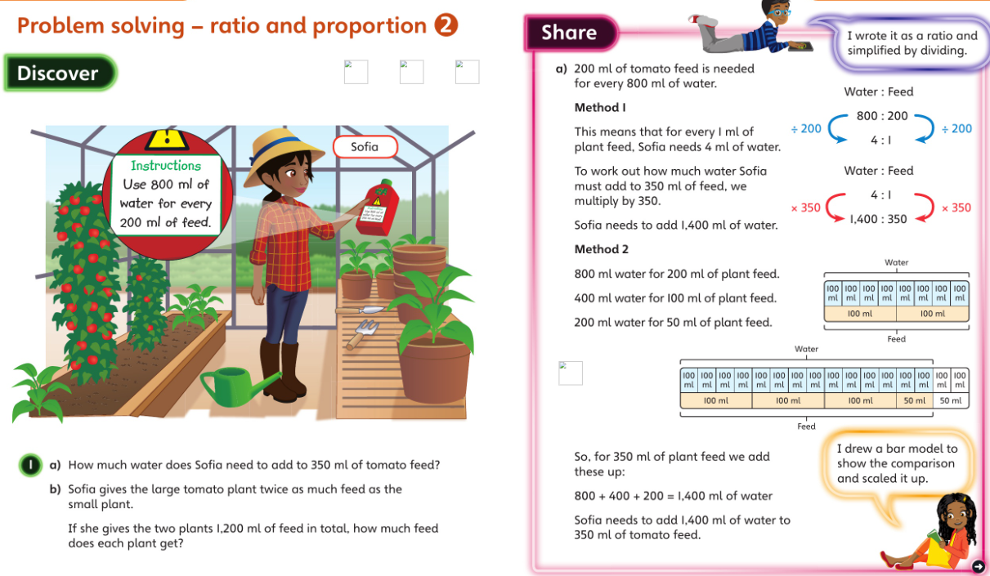**Friday**

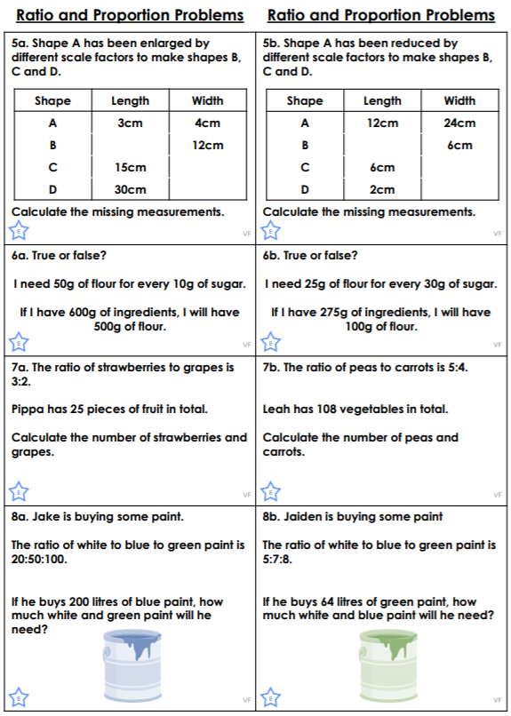

____L white

____L blue

____L white

____L green

________ peas and _________ carrots

________ strawberries and _________ grapes