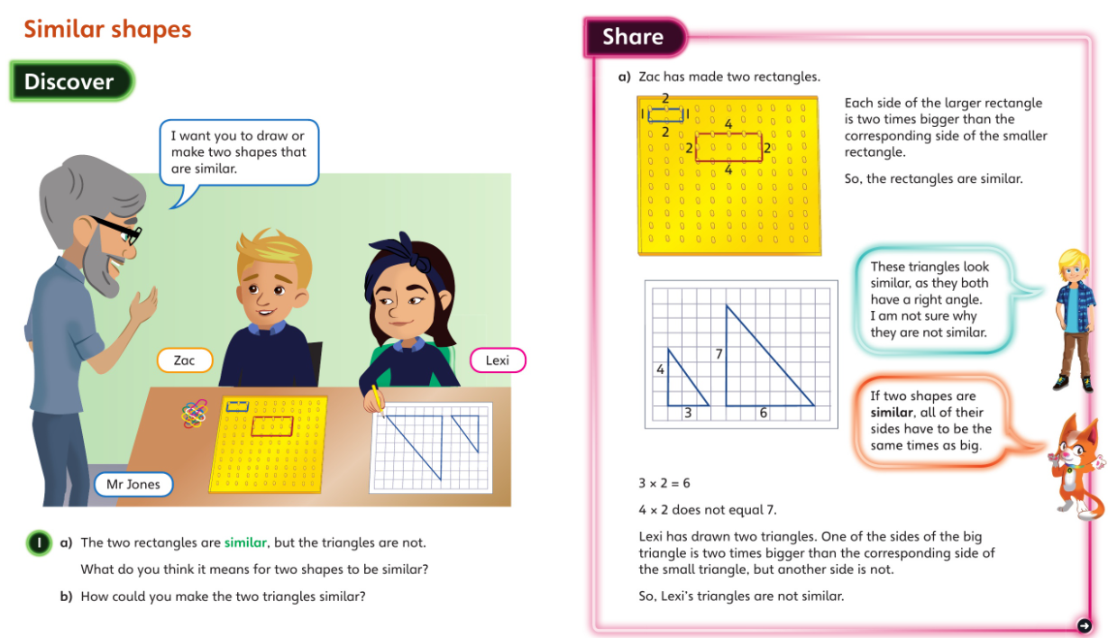**Wednesday**

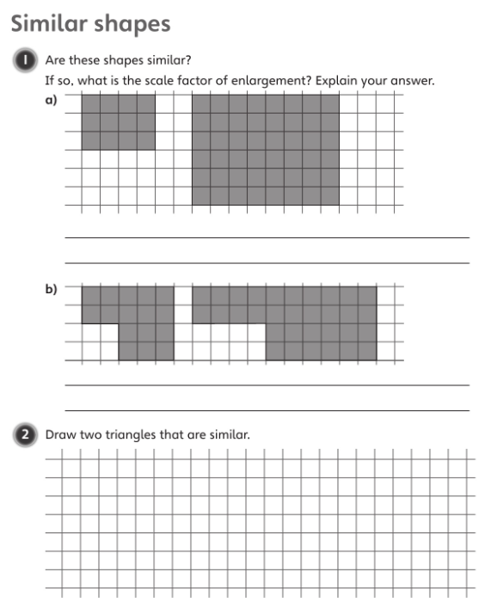

**If you are completing this on the computer, use the insert tab along the top, then go to the dropdown ‘shapes’ menu and select straight lines to draw your triangles.**

