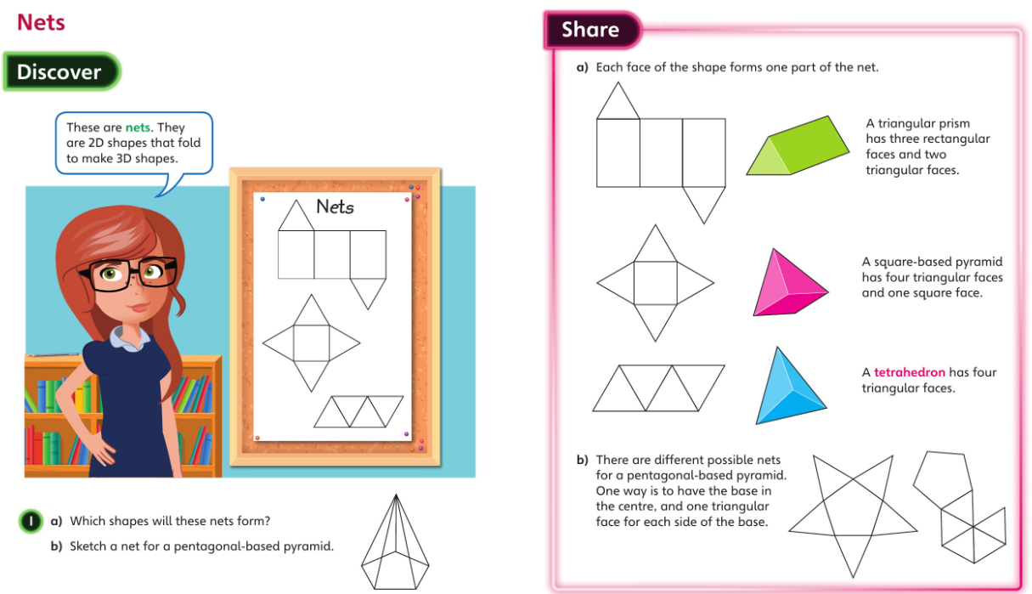**Thursday**

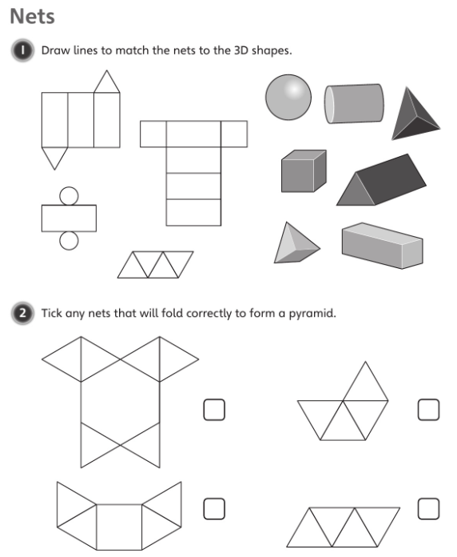

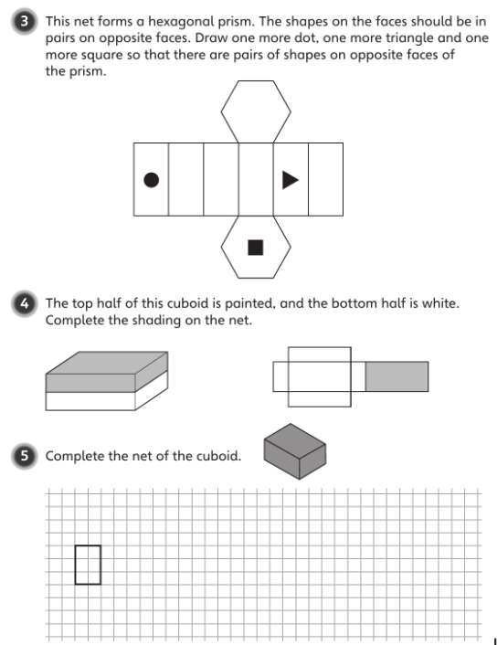

**Click and drag the shapes to the correct position**

**If you are doing this on the computer, use the insert tab and go to the ‘shapes’ dropdown menu to select a rectangle shape.**