**Life on Robben Island**

The low, scrubby oval of Robben Island, a few miles offshore, can be made out from any of the heights around Cape Town. During the apartheid era, it was a place forbidden to all but the inmates and their jailers.

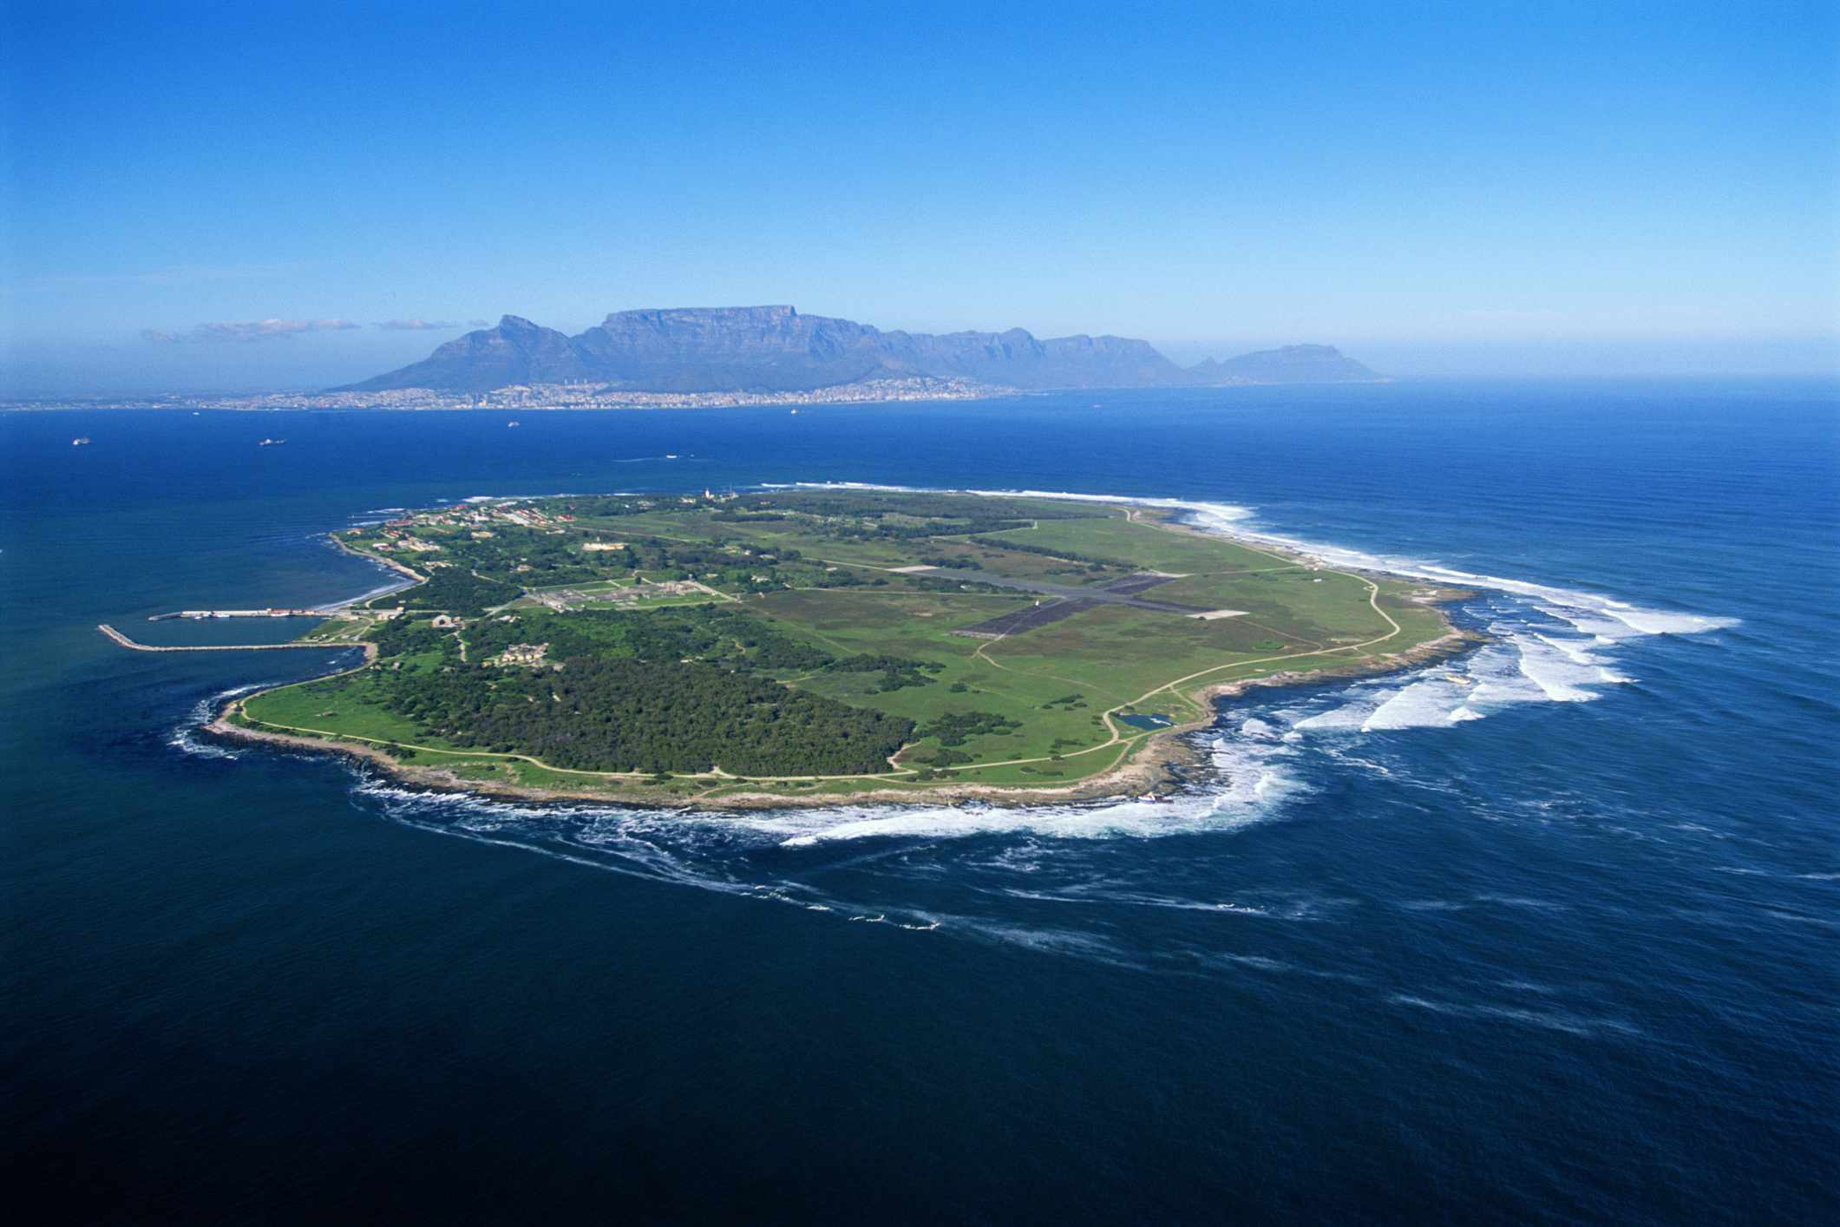South Africans called it simply “The Island”, and speculated fearfully as to what went on there. Yet when Nelson Mandela was asked how his 27 years in prison, most of them on Robben Island, had affected him, his answer was unexpected. “I came out mature,” he said.

The island prison with the city of Cape Town (South Africa) in the background. No one could escape because the waters are shark infested and the current is too strong to swim against.

“Journeying to Robben Island was like going to another country,” Mandela wrote in his autobiography, Long Walk to Freedom. “Its isolation made it not simply another prison, but a world of its own.” He first saw it in May 1963, having been sentenced the previous October to five years for sabotage.

Mandela recalls his first arrival on the island in his book: “We were met by a group of burly white warders shouting [in Afrikaans]: ‘Dis die Eiland! Hier gaan julle vrek!’ (This is the Island! Here you will die!)” Immediately he showed the spirit of resistance that helped to carry him through, telling his fellow inmates to walk when the warders were shouting at them to run, and threatening legal action against one notoriously brutal figure who seemed about to hit him.

While Mandela was never assaulted (physically beaten) during his prison term, everything about the regime was designed to punish and humiliate black leaders who had had the temerity (confidence) to demand equality with whites.

Category D political prisoners like him were allowed one 30-minute visit and one letter every six months. Anything deemed “political” in the letters would be cut out, so that often the prisoner received nothing but a tattered piece of paper that could barely be read.

Even among inmates there was racial discrimination – Mandela recalled that he and other African prisoners were given shorts to wear, while Ahmed Kathrada, the only Asian among the group of African National Congress leaders who arrived on the island together, received long trousers (shorts were not suitable in the cold and made the black prisoners feel like children/schoolboys which was a form of humiliation). Africans also had a worse diet than Asian or mixed-race (the so-called “coloured”) inmates. Removing these inequalities was among the first of many issues on which Mandela and his fellow political prisoners mounted campaigns of passive resistance during their years on Robben Island.

Despite poor food, inadequate clothing in the wet and windswept Cape winter, and heavy labour (work) in the island’s lime quarry, where Mandela’s sight was damaged by the blinding glare of the sun on the quarry’s blanched walls, he remained unbroken. “The challenge for every prisoner, particularly every political prisoner,” he wrote, “is how to survive prison intact, how to emerge from prison undiminished, how to conserve and even replenish one’s beliefs... The authorities’ greatest mistake was to keep us together, for together our determination was reinforced. We supported each other and gained strength from each other.”

Mandela took pains to remain physically fit, and was one of the few who did not complain when the authorities made the prisoners walk to the quarry rather than being taken by truck. He saw it as an opportunity to view the island’s wildlife.

(Extracts taken from an article written by Raymond Whitaker for The Independent on 10th December 2013 with extra information added in brackets by Miss Edwards)