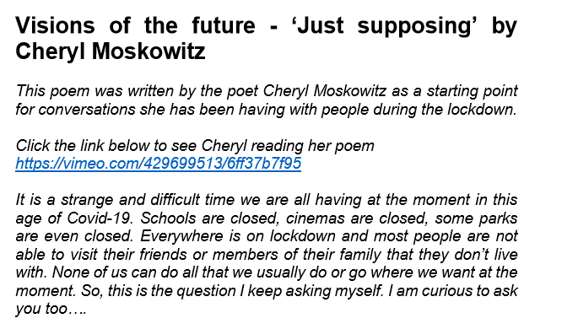**Monday poetry task**

**Link to copy and paste:** [**https://vimeo.com/429699513/6ff37b7f95**](https://vimeo.com/429699513/6ff37b7f95)

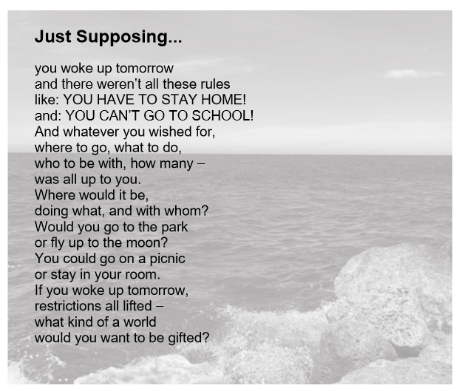

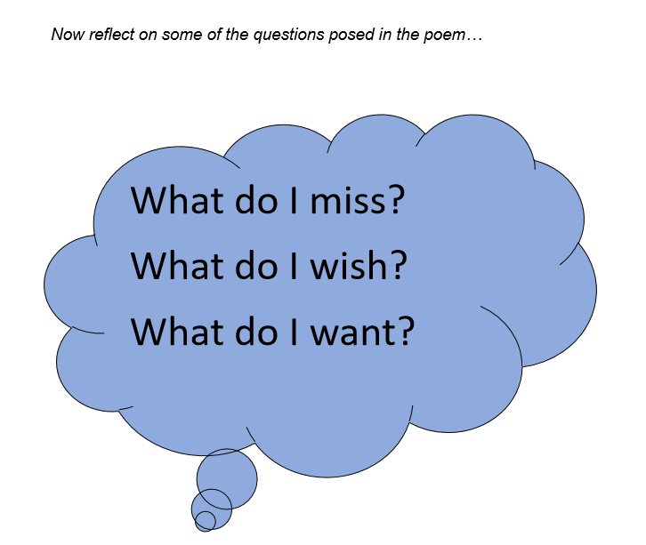

**What I miss/wish/want**

