**Monday task: A more detailed look at Nelson Mandela and prison**

<https://www.youtube.com/watch?v=phwZHln8-l8> – Nelson Mandela’s video story

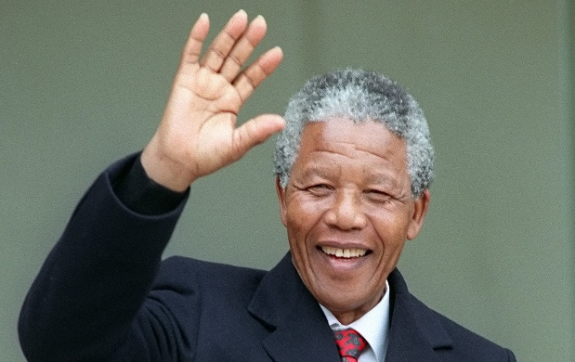

**What did Nelson Mandela believe in? What did he want South Africa to be like?**

<https://www.natgeokids.com/uk/discover/history/general-history/nelson-mandela/>

**Why was Nelson Mandela put on trial and sent to prison?**

<https://www.natgeokids.com/uk/discover/history/general-history/nelson-mandela/>

<https://www.ducksters.com/biography/nelson_mandela.php>

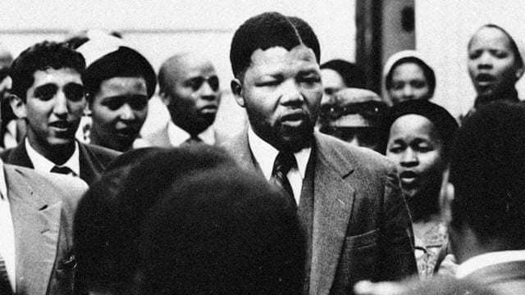

**What were the conditions like in Robben Island prison?**

(See the information sheet in your folder for information on this)

