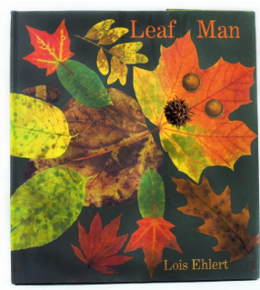
My prediction

What do you think the story is going to be about?__________________________________________________________.
What characters do you think will be in the story?___________________________________________________________.
How do you think the story will end?____________________________________________________________.

