**RE – Sikhism – lesson 4**

This week we’re going to be continuing to learn about the Gurdwara.

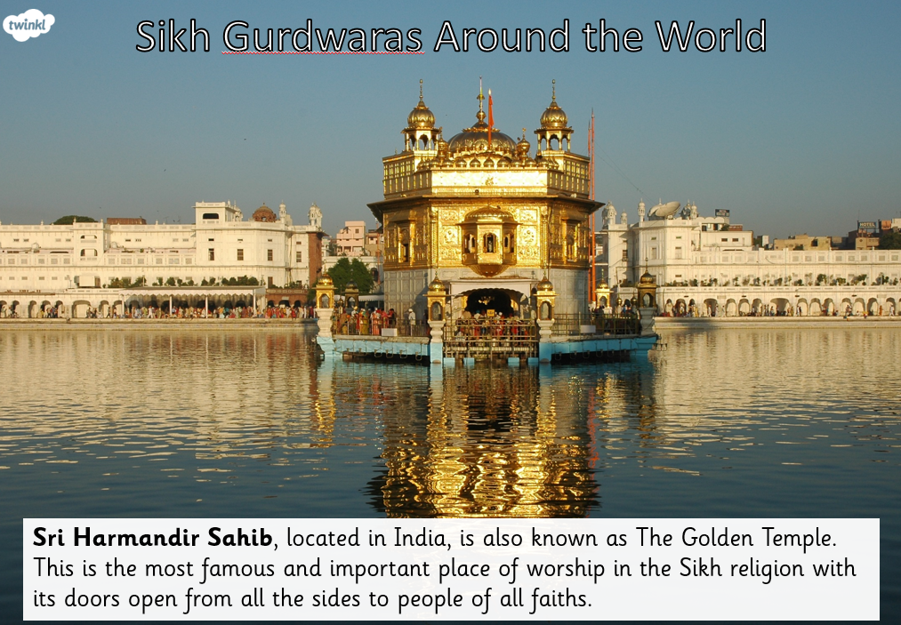

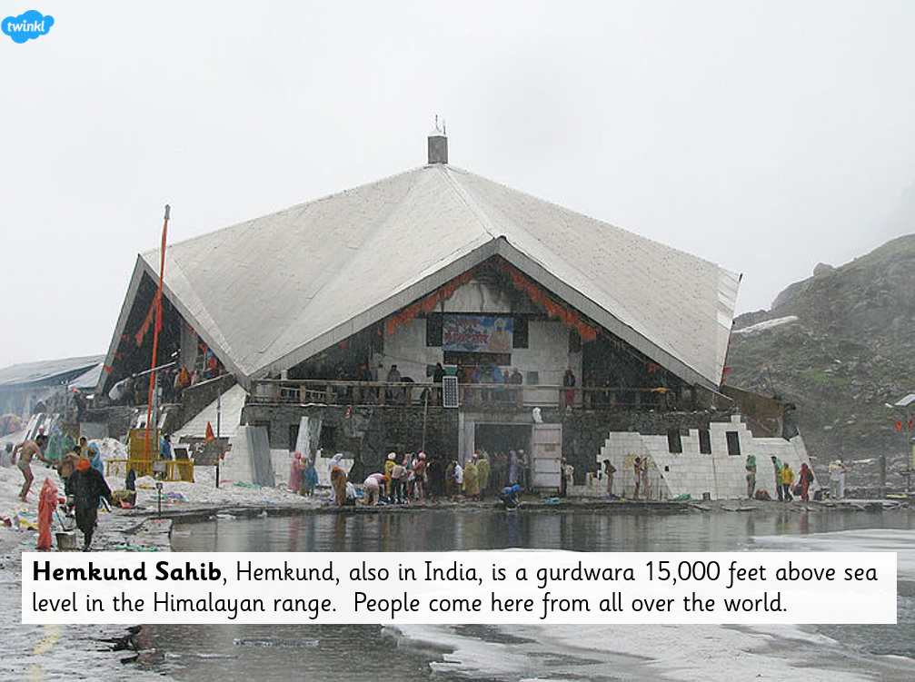

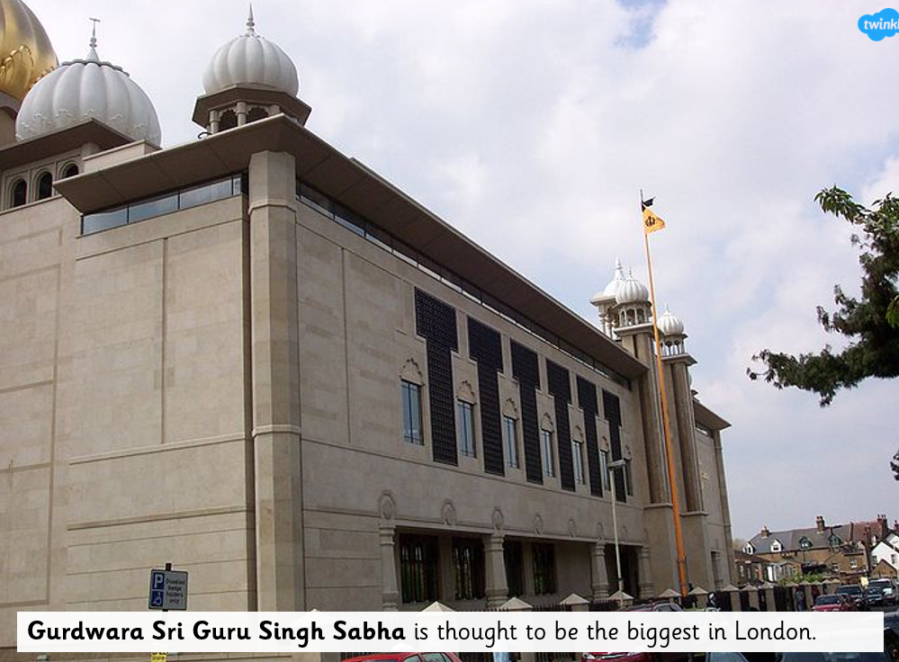

Watch the video:

<https://www.bbc.co.uk/bitesize/clips/zkr87ty>

Because Sikhs believe that God has no form, Sikhs do not have images of God in their place of worship, the gurdwara. Sikhs do have pictures of holy people, eg Guru Nanak, the founder of Sikhism. However, they **do not worship the Gurus**. Rather, in public worship they remember the Gurus, listen to their teachings and share food, reinforcing the equality of all.

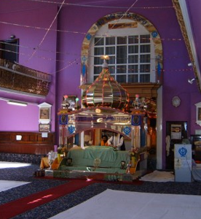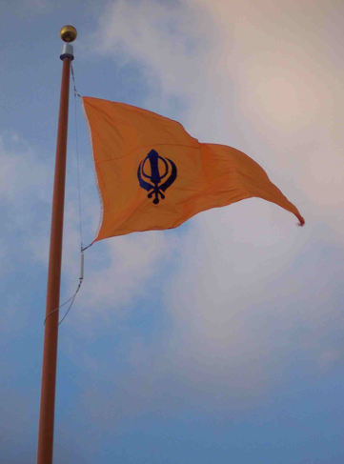Gurdwaras have a flag, known as the **Nishan Salib**, which flies outside the building to let people know it is a place of worship. Traditionally, Gurdwaras will have four doors, to signify the fact that they welcome people from the north, south, east and west. When people arrive, they are asked to remove their shoes and place them on shoeracks. People are also expected to cover their heads.

Worship in the gurdwara takes place in a hall called a **diwan**, meaning 'court of a ruler'.

Each morning the holy book, called the **Guru Granth Sahib,** is carried in procession into the diwan and placed on a **takht**, a raised platform with a canopy called a **Chanani** over it to show that it is the ruler of the Sikhs.

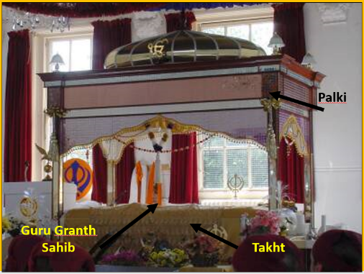The Guru Granth Sahib is covered with beautiful cloths called **rumalas**. An attendant waves a decorative fan, called a **chauri**, over it to purify the area before reading the scripture.

Sikhs remove their shoes, cover their heads and bow before the Guru Granth Sahib when they enter the room. They make an offering of money or food for the gurdwara's kitchen, which is known as the **langar**.

Everyone sits on the floor, men on one side, women on the other. Services are informal and may last a long time, so people come in and out as they wish.

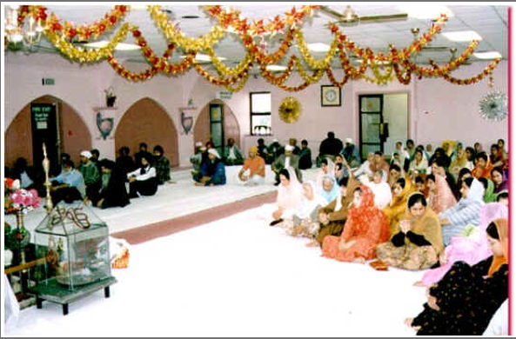

Task 1:

Can you match the features of the Gurdwara to their descriptions?

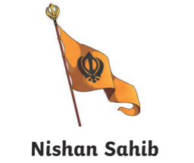

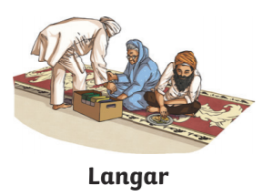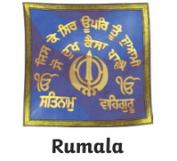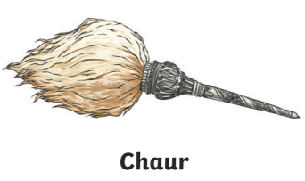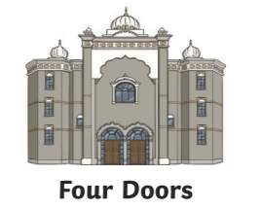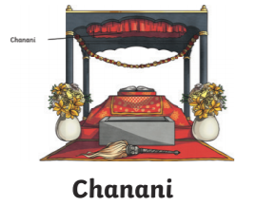

This is a free communal kitchen. Everyone is expected to sit and eat together to show that they are all equal.

This is a canopy made from cloth. It covers the Guru Granth Sahib from above.

This is a special cloth that is placed on the Guru Granth Sahib when it is not being read. It is made from silk and embroidered.

These show that all people are welcome. They are built to represent the north, south, east and west.

This is a fan that is waved over the holy book. It is made from yak’s hair.

Wearing shoes in the prayer hall is considered disrespectful, so they are stored here.

This is a flag that shows that it is a place of worship. It has the Sikh symbol called the ‘Khanda’ on it.