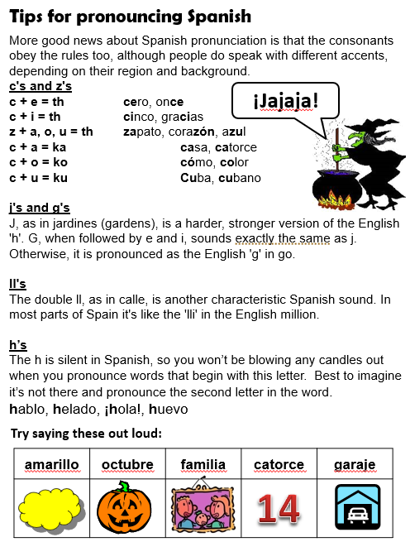

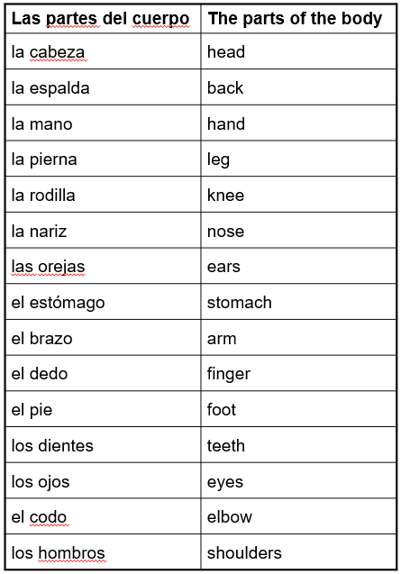

Try Head shoulders knees and toes in Spanish here:

<https://www.youtube.com/watch?v=nUklGzMrHQg>

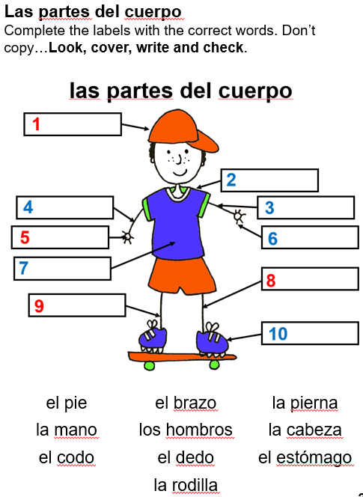

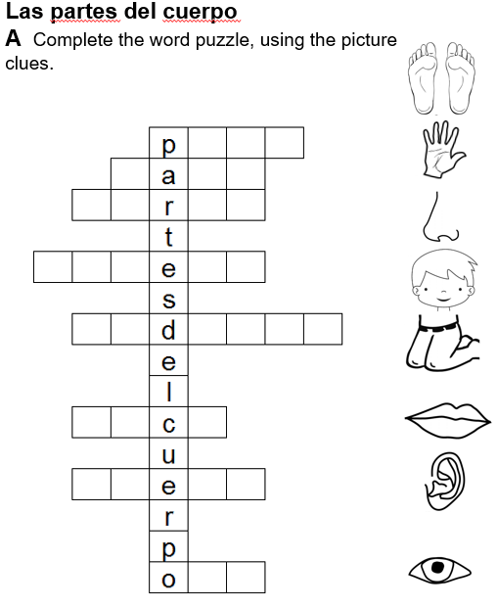

Spanish has the same rules as English for plurals. When there is more than one, you add ‘s’ to the end. When you have a word ending in ‘s’ for a pair, you remove the ‘s’ to talk about the singular. Eg. brazos (arms), brazo (arm).