Spreading my wings from Year 1 to Year 2
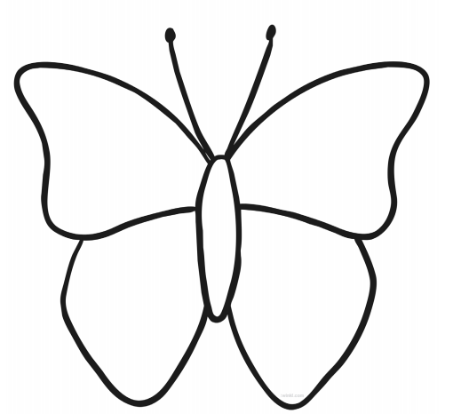
I want to get better at…
I am good at…
I like learning…
My friends are…

