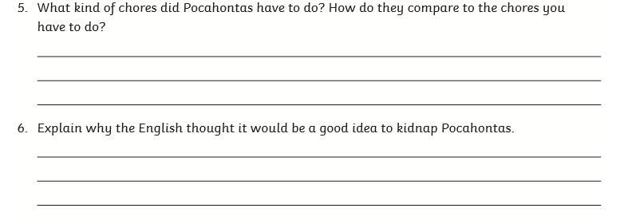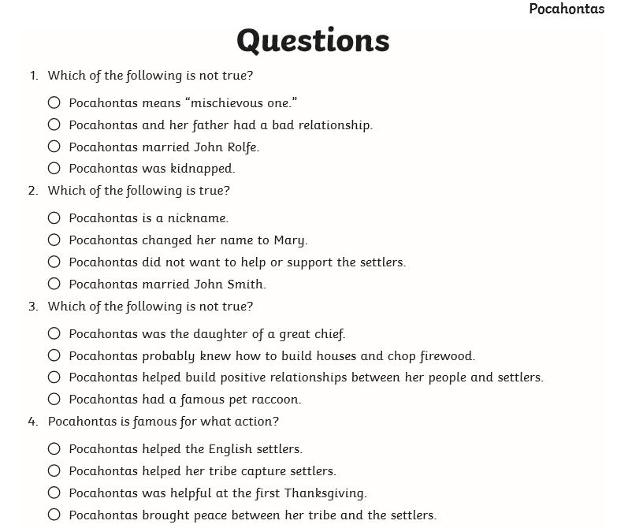**Thursday reading task: Pocahontas**

Your answer:

Your answer:

Your answer:

Your answer: