Write a letter to yourself.
Keep it safe and don’t open it until the end of the year 3, so you can look back on how much you have grown and what you have achieved.
Things to include in your letter:
What do you want to achieve next year?
What do you hope to have learned?
What do you hope to have got better at?
Draw around your hand on the back of your letter so you can see how much you have grown at the end of the year!
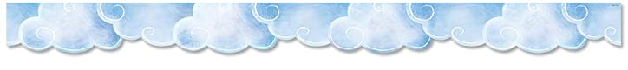
Get your grown up at home to keep it safe.

Dear Me,

