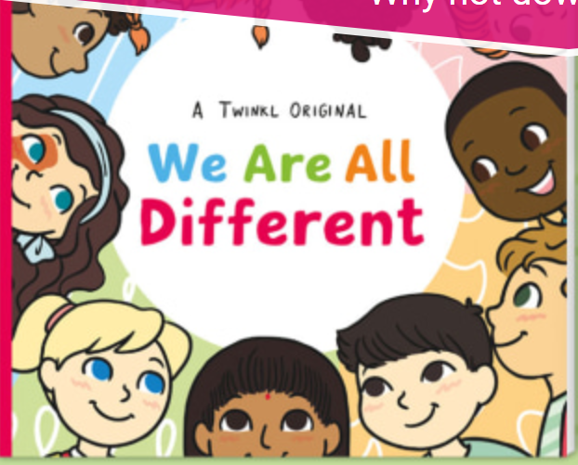Have a look at the e-book – ‘We are all different’
We are all different and it is important we understand and celebrate each other’s differences. The children in the book enjoy different things, look different and live with different families. Being different is what makes us special – a world filled with everyone the same would be rather boring.
We would like you to complete a ‘role on the wall’ all about yourself. Draw a big picture of yourself – on the inside list personal things all about you. This could include:
- Things you like
- Things you dislike
- What you enjoy
- Special places you like to visit
- The things or people you love
On the outside write words and phrases to describe what you look like.
Then, use your ideas to write a little paragraph about yourself.
Write in here

