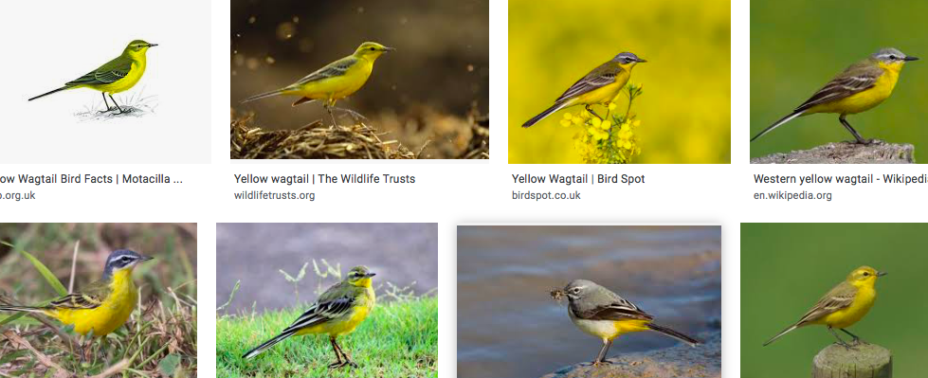
Kingfishers you are going to be wagtails

Sparrows you are going to be Merlins

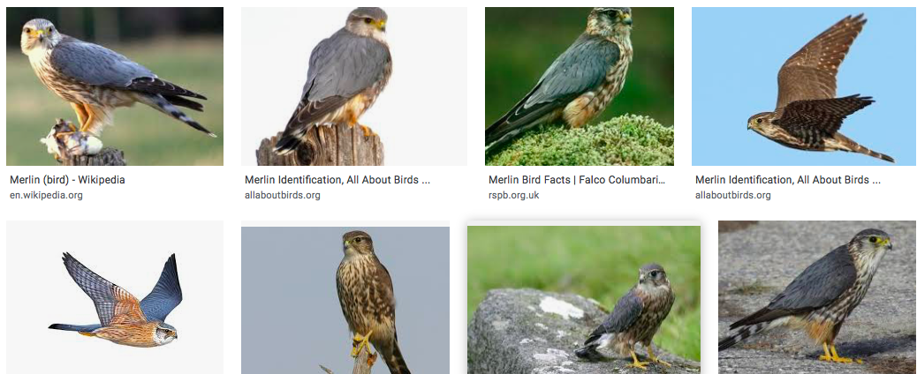
Facts to find out about your new class bird:

Where and when you can see them?
Where/ what is their habitat?
Where do they nest?
What colour are they? Do they have any special markings?
What do they feed on?
Size?
Any Interesting or special facts?

Can you now get creative and draw a picture of your new class bird? You could use paints, colours, felt tips or natural resources. Really take your time to create a beautiful picture of your class bird.

