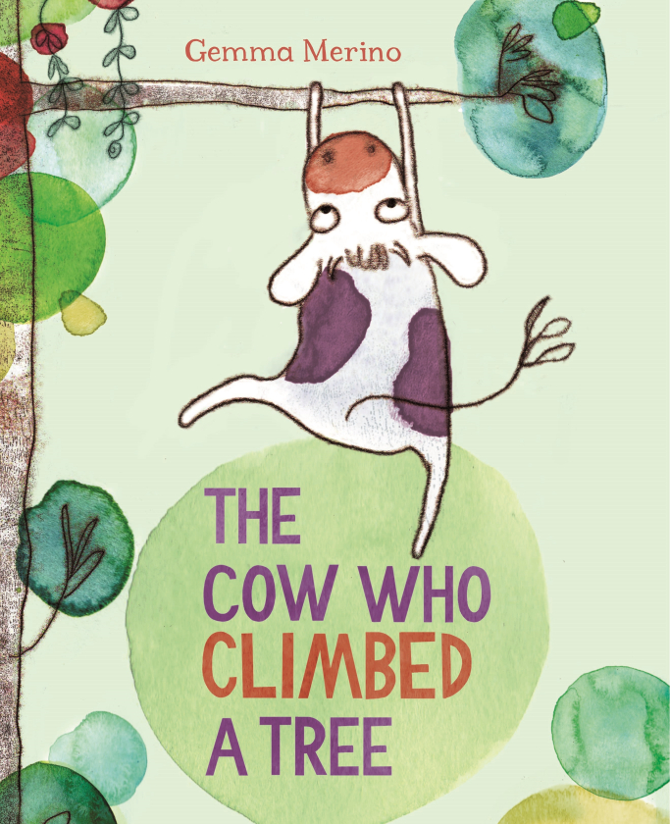
https://www.youtube.com/watch?v=3gF1R6QP_cE
Tina’s sisters only care about fresh green grass because this is something that is familiar to them.

Tina isn’t like the other cows; she believes the sky is the limit and nothing is impossible. She decides to try something new and finds a world full of surprises!

It’s time for you to start thinking about year 3, This might make you feel worried as it means change.
How are you going to be like Tina the cow and push yourself to try something new and hopefully discover some amazing things in year 3?

Remember one of our secrets of success is to push yourself, working towards your wristband would be a great way to start year 3

Write a list of new things you would like to try in year 3 or how you are going to push yourself to be the best learner you can be.

