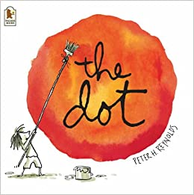
Read the story about a teacher who helps a little girl develop a ‘can do’ attitude when she comes back to school.

https://www.youtube.com/watch?v=Clpw7PG7m1Q

At Keys Meadow having a ‘can do’ attitude and believing you can be anything you want to be is so important.
We have been away from school for a long time now, so even coming back to school might make you feel a little nervous. Remember you will have all your friends in your class, and you will see all the adults you know and trust around school. You can do it, You can fly!

Let’s be like Vashti from the story and create our own dot-based Artwork. Have a look at these dot-based pieces of art for inspiration.
Can you remember what Art is called when it is created by dots? We had a go at doing it in ICT….
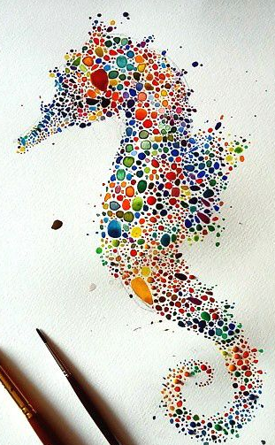

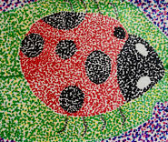
It’s called Pointillism! See what you can create!!

