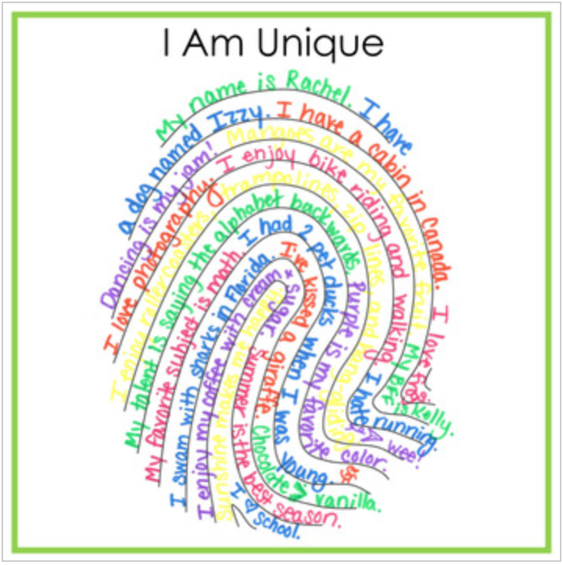
Have a look at all the information you wrote about yourself yesterday.

This information is what makes you unique and special.
Unique means ‘being the only one of its kind; unlike anything else’

Remember the story – the children also described things they like to do. This also makes us different as we all have different likes and dislikes.

Activity: Think back to all things you wrote about yourself and how this makes you unique.
Have a look at your fingers. Each finger has a unique print that now one else has. Can you make a finger print all about you? Fill it with sentences which make you unique.

Share your print with your family or friends. Ask them if they made one would it be the same or different. Is anyone exactly the same as you?

