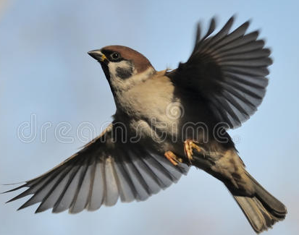
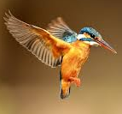

Spreading my wings from year 2 to year 3
A letter for your new teacher

What you are most looking forward to in year 3?
Is there anything you are feeling worried about?
Who are your friends at school?
Your favourite subjects at school and why?
Your hopes, dreams and what you want to achieve in year 3?
What you are confident at?
What you sometimes need help with?
A list of things you would like to learn this year?

This is a chance to really show your new teacher just how much of a great writer you are and how much effort you put into your learning, as well as explain all about you.

Please take your time with this letter and remember everything you have learned in year 2. Think about using a range of punctuation, extend your sentences with conjunctions, use paragraphs, think about your presentation if you are writing it and check your spellings.

Show your new teacher just how amazing you are!

