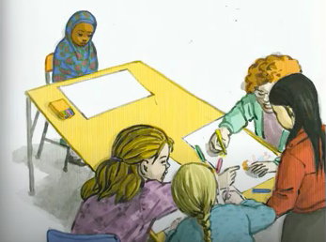
After moving to a new country, Bilal has to start at a new school. Bilal is anxious she will look different to her new class mates. Bilal is worried she is going to feel excluded or be teased by the other children in the class.

If you could write a letter to Bilal, what would you say?

Think carefully about what we have been thinking about, we are all unique and discriminating is wrong. Diversity and our differences should always be celebrated and accepted.
How could we help Bilal to understand that?
What would you say to her?
How would you welcome Bilal if she started in your class?
If she did feel teased or excluded, what advice could you give her? What should she do?
Dear Bilal,

Dear Bilhal

