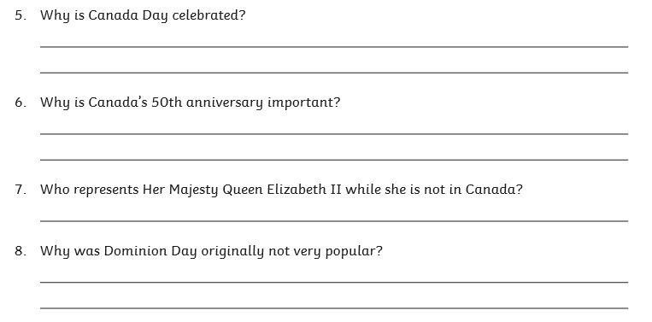**Tuesday reading task: Canada Day**